# **Welcome**

Acknowledgement

City of Newcastle acknowledges that we operate on the grounds of the traditional country of the Awabakal and Worimi peoples.

We recognise and respect their cultural heritage, beliefs and continuing relationship with the land and waters, and that they are the proud survivors of more than two hundred years of dispossession.

City of Newcastle reiterates its commitment to address disadvantages and attain justice for Aboriginal and Torres Strait Islander peoples of this community.

**Table of Contents**

Welcome 1

Our Newcastle 5

Benefits and trends of social infrastructure 13

Innovation and best practice trends 16

Our strategy 19

Our priorities 25

Priority 1: Equitable distribution for growth and resilience 26

Priority 2: Quality and adaptive places and spaces 29

Priority 3: Community capacity-building and inclusion 33

Priority 4: Governance, partnerships, and advocacy 35

Appendix 37

Appendix 1 – Action Plan 37

Appendix 2 - Catchment planning and demographics 41

Appendix 3 – What our community told us 46

**Lord Mayor Foreword**

City of Newcastle (CN) recognises that investment in quality social infrastructure is essential for the health, social wellbeing, and economic prosperity of our city. It plays a significant role in enhancing the lives of people of all ages, background, and abilities, and a city's overall prosperity and liveability.

Through our Social Infrastructure Strategy (SIS), we identify these social and economic benefits that equitably delivered, and sustainably managed social infrastructure will bring to our individual community members and our community as a collective, whilst outlining contemporary challenges, emerging needs and opportunities we face.

The SIS will inform the planning, investment, negotiation and delivery of social infrastructure for our city. It outlines our high priority directions and actions, and acts as acts as a decision-making tool for which future social infrastructure demand is assessed, planned and social delivered – allowing us to guide our commitment for investing in, partnering and delivering public places.

Meeting community needs and aspirations for our city's social infrastructure will require a whole-of-community and whole-of-government response involving greater coordination, cooperation, and partnership between each level of government, community sector and industry to address unmet need and alleviate pressure on existing services and infrastructure. It will steer CN to undertake this work through an 'integrated approach' - working better, together.

Thank you to those who have assisted to inform the development of the strategy, and to the many who contribute to Newcastle's array of valued social infrastructure, enhancing our city's overall liveability daily. I look forward to championing the implementation of this strategy over the next four years.

**Councillor Nuatali Nelmes**

Lord Mayor of Newcastle

# Our Newcastle

**Community Strategic Plan – Newcastle 2040**

*Newcastle is a liveable, sustainable, inclusive global city*

*Newcastle 2040* is CN’s Community Strategic Plan (CSP) and is the highest level of planning we undertake at the local government level. *Newcastle 2040* is a shared community vision, developed as a guide to inform policies and actions throughout the city for the next 10+ years. For those who live, work, play and study in Newcastle, this vision sets the direction for how we want our city to grow. With direct input from a wide cross-section of the community, it represents what we value in our city and what we want to prioritise.

In 2040, Newcastle will be a liveable, sustainable and inclusive global city. We will celebrate our unique city and protect our natural assets. We will optimise opportunities and build resilience in the face of future challenges. We will champion inclusion so that everyone is valued, and we will encourage innovation and creativity. As we make our way towards 2040, we will work together to achieve our vision by building trust and collaborative relationships.

To guide us forward, we will focus on four themes that emerged from our shared planning process. These themes work together in harmony to deliver our vision for Newcastle as a place for everyone.

Newcastle at a glance

***Our population***

Newcastle population 2022

**173,356**

Population by 2041

**202,049**

Greater Newcastle population 2021

**608,700**

Population by 2041

**699,200**

Estimated annual population growth rate **1%**

**Median age**

Newcastle 37

NSW 37.9

**Aboriginal and Torres Strait Islander** **population**

Newcastle 3.5%

NSW 2.9%

**Born overseas**

Newcastle 13.9%

NSW 27.6%

**Speak a language other than English**

Newcastle 10%

NSW 25.1%

134 different languages spoken at home – most widely spoken included Mandarin, Macedonian, Italian, Greek, and Arabic. Languages spoken with greatest need for translation included Arabic, Mandarin, Swahili, Persian/Dari and Tibetan.

**Number of people living with disability**

Newcastle 5.9%

NSW 5.4%

Defined as people needing help or assistance in one or more of the three core activity areas of self-care, mobility and communication, because of a disability or long-term health condition.

**[1]**

**People**

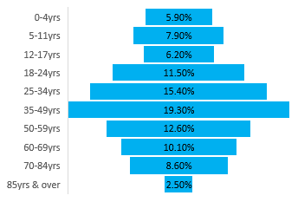

i. Planning NSW Population Projections, forecast.id

How we are growing and changing

**Forecast population growth**

Our city is growing and changing. Newcastle’s population is forecast to grow by more than 40,000 people by 2041, placing increased pressure on social infrastructure (SI) and driving demand for new infrastructure, particularly in high growth areas such as Maryland–Fletcher–Minmi, Wallsend–Elermore Vale, Newcastle–Cooks Hill and Mayfield–Warabrook.

**Diversity across our places**

Newcastle is a large city and our communities differ from place to place. Fit-for-purpose planning is important because different places, communities and activities have unique needs and challenges. The quality, ease of access and experience of SI varies across different places and types of infrastructure, particularly for vulnerable groups of people and in fast-growing and older areas.

**Change in age profile​**

There is population growth across all age groups; however, between 2016 and 2041, the highest growth will be in:​

* Parents and homebuilders, 35–49 years: +8,519 (28%​)
* Seniors, 70–84 years: +6,946 (52%​)
* Young workforce, 25–34 years: +6,041 (24%)​

**Growth in number of dwellings​**

The number of dwellings in our area will increase from 69,245 to 88,747 (an additional 19,502 dwellings), particularly in the high-growth areas of Maryland–Fletcher–Minmi, Wallsend–Elermore Vale and Newcastle–Cooks Hill.​

**Changes in housing type​**

While growth in the west will mainly be through single dwellings, in areas such as Newcastle City Centre, Mayfield (Maitland Road), and around Broadmeadow, Adamstown and Hamilton Stations, growth will be in apartments. As well as increased density, this will result in a need for public facilities that provide spaces to connect outside of the home, and for public open space that functions as a ‘backyard’ for apartment residents.

**Our global commitment**

*The SDGs underpin our work*

In September 2015, 193 countries committed to the United Nations Sustainable Development Goals (SDGs). These goals provide a global roadmap for all countries to work towards a better world for current and future generations.

CN immediately declared our support and intention to deliver the SDGs and began proactively implementing action and engagement. We are committed to contributing to the achievement of the SDGs and have been working towards increasing and improving our contribution to this shared global vision.

The SDGs are significant and will take time to achieve. However, it is important to recognise the steps we are taking to progress these goals. Of the 17 SDGs, the SIS has core alignment with SDG Goals 3, 4, 9, 10, 11 and 17, as outlined below.

|  |  |  |
| --- | --- | --- |
| **SDG** | | **How is it addressed in the SIS?** |
|  | Ensure healthy lives and promote well-being for all at all ages | The Strategy prioritises high-quality, comfortable public spaces such as parks, community centres, and recreational blue and green grid links to support our community in improving health and wellbeing outcomes. |
|  | Ensure inclusive and equitable quality education and promote lifelong learning opportunities for all | The Strategy prioritises community access to lifelong learning opportunities through libraries and access to quality early education, care and school services for children. |
|  | Build resilient infrastructure, promote inclusive and sustainable industrialization and foster innovation | The Strategy prioritises industry innovation through improved access to technology and new approaches to delivery such as co-location, sharing and partnership. |
|  | Reduce inequality within and among countries | The Strategy prioritises more equitable access to universally designed and affordable SI, particularly for our more socially, economically and transport-disadvantaged residents. |
|  | Make cities and human settlements inclusive, safe, resilient and sustainable | The Strategy prioritises understanding the unique needs of all members of our community, ensuring they have access to the basic social services they need to reach their full potential. |
|  | Strengthen the means of implementation and revitalize the Global Partnership for Sustainable Development | To realise the priorities of this Strategy, Newcastle has many opportunities to partner with other agencies such as the University of Newcastle (UoN), Hunter and Central Coast Development Corporation (HCCDC), the Department of Education, local non-government organisations (NGOs), and community, cultural and sporting groups. |

Our policy drivers

Access to high-quality public spaces, including SI, is critical to social, economic and environmental sustainability. Infrastructure Australia’s *2021 Australian Infrastructure Plan* highlights the growing recognition of the role effective SI assets and networks play in supporting the social and economic wellbeing of all Australians.

The 2021 *NSW* *Public Spaces Charter* states that public spaces unlock a broad range of benefits that enrich our lives. Quality SI should be accessible, comfortable and activated.

The Infrastructure NSW *Cultural Infrastructure Strategy 2016* notes that Newcastle needs cultural infrastructure to support its growth into a global city, and identifies the expansion of the Newcastle Art Gallery as a key regional project.

These strategies indicate that over the coming years, the Newcastle Local Government Area (LGA) will see growth and opportunities for SI outcomes, including in Newcastle City Centre, Broadmeadow/Hunter Park and Callaghan. Growth along the urban renewal corridors of Waratah, Hamilton–Georgetown, Lambton, Newcastle City Centre, Adamstown–Kotara, Merewether and Minmi will also create opportunities for SI.

*City of Newcastle*

The SIS is interrelated with several CN strategies and plans, including some required under legislation such as the NSW Environmental Planning and Assessment Act 1979 or the NSW Disability Inclusion Act 2014.

* Community Strategic Plan: Newcastle 2040
* Local Strategic Planning Statement
* Local Housing Strategy 2020
* Fern Bay and North Stockton Strategy
* Section 7.11 and 7.12 Development Contributions Plans 2022
* Draft Local Social Strategy 2022 - 2026
* Disability Inclusion Action Plan 2022 - 2026
* Reconciliation Action Plan 2021 - 2024
* Economic Development Strategy 2021 -2031
* Library Strategy 2019-2029
* Strategic Sports Plan 2020
* Dogs in Open Space Plan 2019

Our *Community Strategic Plan: Newcastle 2040* has several relevant objectives, including:

* Priority 1.1 – Enriched neighbourhoods and places
* Priority 1.2 – Connected and fair communities
* Priority 3.4 – City-shaping partnerships
* Priority 4.1 – Inclusive and integrated planning.

As outlined in our *Local Strategic Planning Statement* (LSPS), high-quality SI supports our evolution from a regional city at the heart of the Hunter into a smart, liveable and sustainable global city. Key priorities include:

* Priority 1 – Prioritising active transport in our city
* Priority 4 – Greening our neighbourhoods
* Priority 8 – Planning for growth and change in catalyst areas, strategic centres, urban renewal corridors and housing release areas
* Priority 9 – Sustainable, healthy and inclusive streets, neighbourhoods and local centres.

In our draft *Local Social Strategy*, our people are placed at the centre of a vision for a socially just and inclusive Newcastle for all. The Strategy seeks to remove barriers to inclusion and equal opportunity, encourage community connection and participation, celebrate our rich social and cultural diversity, and strengthen community health and wellbeing. Key priorities include:

* Priority 1 – Equitable communities
* Priority 2 – Inclusive communities
* Priority 3 – Connected communities
* Priority 4 – Healthy communities.

The Library Strategy 2019-2019 outlines a long-term vision for a world class library service in Newcastle — anywhere, anytime, open and accessible 24/7. The Library *Strategy also* focuses on building and information technology to guide future library infrastructure development to ensure it meets the needs of a continuously adapting and evolving city. The Strategy identifies a need for CN to invest in lifelong learning, community participation and co-location, enhanced library spaces, and digital transformation. Physical infrastructure is one element of the long-term vision expected by the community aligned to improved community service points, and flexible service delivery options.

The Strategic Sports Plan address future demand, and inform the ongoing supply, maintenance and upgrade of sporting infrastructure with consideration to current and future needs of the community, other adopted strategies and City of Newcastle’s financial capacity and sustainability.”

The Liveable Communities focus area of our *Disability Inclusion Action Plan (DIAP) 2022 – 2026* is about creating opportunities for social participation, improving the quality of personal interactions and ensuring equivalent access to places, spaces and information. There is a direct relationship between the SIS and the DIAP through the continued focus on access and inclusion for all members of our community in the public places and spaces across Newcastle.

Our role

We are just one of many agencies that have a role in SI outcomes. All levels of government (federal, state and local), industry, NGOs and the private sector have various responsibilities for the funding, planning and delivery of SI.

CN contributes to SI through our community and cultural facilities, libraries, recreation and open spaces, services and programs. Along with delivering and maintaining physical places and spaces, CN s advocates for public benefit through local policy, planning and regulatory frameworks as well as supporting business innovation, investment and industry growth.

Depending on the activity being undertaken, CN’s role can include the following:



**Research and strategy**

Developing an evidence base to better understand, plan and advocate for the community, and developing policies and plans that respond to community needs

**Leadership**

Identifying key community issues and stakeholders to respond where appropriate

**Connections**

Identifying and connecting different contributors to encourage innovation, maximise social outcomes and support social cohesion

**Advocacy**

Drawing on our research and partnerships to advocate for our community to other levels of government and amplify the work of our local partners

 

 

**Delivery**

Designing and delivering programs and initiatives that align with key strategies, plans and community needs, ensuring community engagement and involvement

**Partnerships and grants**

Partnering with organisations and communities to achieve shared goals, including through grants



**Infrastructure**

Planning and delivering places and spaces that promote social connectivity, inclusion and a sense of belonging

**Capacity-building**

Unlocking capacity within the community by equipping people with the skills they need to achieve social outcomes

# **Benefits and trends of social infrastructure**

***Social infrastructure is what brings our people together. It is the places, spaces, services and programs where connections are made, where we learn and grow, and where we stay active and healthy. For many of us, these places are our second home.***

Hard and soft infrastructure

Infrastructure Australia (Australian Infrastructure Audit, August 2019) defines SI as: *‘… the facilities, spaces, services and networks that support the quality of life and wellbeing of our communities. It helps us to be happy, safe and healthy, to learn, and to enjoy life. The network of social infrastructure contributes to social identity, inclusion and cohesion and is used by all Australians at some point in their lives, often on a daily basis.’*

Successful SI relies on the availability of facilities and spaces for services, programs and activities. It includes:

|  |  |
| --- | --- |
| Basketball Hoop outlineModern architecture outlinePlayground outlinePark scene outlinePerformance Curtains outlineSoccer Goal outline | **Hard infrastructure:** streets, footpaths and urban public places where social connection and exchange happens. Facilities or physical structures where social, cultural and recreational services, programs and activities are delivered or operate |
| Dragon dance outlineArtist male outlineTypewriter outline  Badminton outlineFamily with girl outlineBoardroom outline | **Soft infrastructure**: Services and programs that are delivered via hard SI |

|  |  |  |
| --- | --- | --- |
| **Hard Social Infrastructure** | | **Soft Social Infrastructure** |
| Public places   * Streets and footpaths * Civic spaces and town squares * Community hubs, centres and halls * Community meeting and gathering spaces * Libraries * Cultural facilities (museums, galleries, theatres) * Emergency service facilities * Hospitals * Justice and courthouses * Early childhood education and care * Schools * Tertiary (TAFEs and universities) * Co-working facilities | Public spaces   * Sports spaces/fields * Parks * Natural bush spaces (including environmental reserves) * Beaches, lakes and rivers * Public recreation facilities within open spaces * Swimming pools, ocean baths, splash areas * Surf clubs * Playgrounds * Recreation courts * Skate/BMX/leisure parks * Community gardens * Outdoor exercise equipment * Dog exercise areas | * Community, cultural and recreational services, programs and events that contribute to wellbeing and connection, learning and education, cultural development, emergency services, health and social justice * Provides equitable opportunities for all to access social welfare and community services providers, as well as individual activities and programs |

Why social infrastructure matters

The way we plan, deliver and enable our social infrastructure will play an important role in improving equity, accessibility and connectivity across Newcastle. Social infrastructure provides many benefits to the city and its people.

|  |  |
| --- | --- |
| ***Liveability​***  Liveable places have great access to SI that enables lifelong learning, creative expression, and supports social and cultural networks.​  SI contributes to and strengthens the vitality, identity and character of urban centres1. It is ideally situated on​ landmark sites with distinctive architecture and quality design. Local stories and culture can be ingrained in the building fabric to assist in fostering community identity and ownership. In high-density communities, SI improves liveability significantly by having an important role as ‘community living rooms’, ‘community backyards’ and ‘break-out spaces’1.​  1 Infrastructure Australia, ‘Social infrastructure’ in *Australian Infrastructure Audit 2019*, 2019​​ | ***Education and economic growth*​**  SI is instrumental in supporting local businesses: it creates new job opportunities; provides spaces and services that promote learning and development of people; provides spaces for co-working, networking and entrepreneurship; and it activates urban centres.  Libraries, arts spaces and multipurpose urban spaces invite local and tourist participation, in turn generating economic outcomes. This type of investment can provide a revenue​ stream and stable employment to support local economies in regional areas.2​  When located in town and strategic centres, SI such as libraries and multipurpose community centres are a significant attractor, increasing visitation to retail offerings.​  2 McDougall, A. and Savage, G., *Dollars, Sense and Public Libraries: The Landmark Study of the Socio-economic Value of Victorian Public Libraries*, Melbourne: State Library of Victoria, 2011 |
| ***Community connection and resilience***  SI helps to bind people and neighbourhoods together to build social capital, social cohesion and community wellbeing. Research indicates that social connection leads to happier and healthier communities3.SI also builds resilient communities. As 100 Resilient Cities has identified, communities need to be prepared for a range of shocks, stresses and emergencies such as climate change impacts or pandemics.  SI provides the places, services and programs that keep us safe, supply information and build social connections during these situations. This has been highlighted during the COVID-19 pandemic, where SI (such as health services; education facilities; volunteer, cultural and social welfare organisations; and local community groups and centres) has been critical in the local community response.  3 Greenberg, M., ‘Does Being More Social Make Us Happier?’, *Psychology Today*, 2019 | ***Health and wellbeing*​**  SI encourages the public to be physically active and promotes a lifestyle beneficial to mental and physical health. Studies have shown that natural environments such as green and blue spaces contribute to improved mental health, and that increased physical activity reduces anxiety, depression and psychological stress4. Access to public open space, close to where people live, is associated with increased physical activity in all age groups4.  4 Dadvand, P., et al., ‘Green Spaces and General Health: Roles of mental health status, social support, and physical activity’, *Environmental International*, 2016 |

## **Innovation and best practice trends**

***A networked approach***

Planning SI as part of a network means that public places, spaces, services and programs all work together across a neighbourhood, catchment or region. In geographically dispersed areas such as Newcastle, the approach involves the provision of LGA-wide or district public facilities in larger strategic centres, with smaller satellite public places and spaces in local centres providing spaces for outreach services.

Social infrastructure operating as a network

***Increasing the capacity of what we have:* *‘Making it work harder’***

Before any new SI is planned, local government is increasingly reviewing the capacity of what they already have. This involves asking the question: ‘Can existing infrastructure be extended or improved, or is new investment needed?’, and identifying opportunities for repurposing SI that is well located and has the capacity to become modern, flexible and multipurpose.

In the context of unprecedented population growth and increasing community expectations, improving the capacity, efficiency and performance of existing SI will need to be a priority to meet

demand. Opportunities exist to make smaller, more incremental investments where significant capacity enhancements can be delivered through existing infrastructure. This could include placing synthetic turf on hard sports fields or repurposing ageing infrastructure with modern technology to increase amenity and utilisation.

***Co-location within community hubs***

The term ‘co-located hub’ refers to the integration of public space, community facilities and services in one location or building to foster more social connections and provide better access to a wider range of services (or a ‘one-stop shop’ for users), as well as a more cost-effective way of delivering and operating these services. Integrating and co-locating SI within community hubs helps to create key gathering points within a community with a variety of offerings.

The ‘co-located hub', also known as 'community hub’ approach is a way to integrate services, improve community outcomes, facilitate greater partnerships and reduce the cost of delivering stand-alone facilities. Community hubs provide opportunities to attract a range of users, increase access to services and generate critical mass for essential services like public transport.

***Multipurpose, shared and flexible design***

Multipurpose and flexible SI has been a trend for some time, particularly for new buildings. They support a range of different services and programs being delivered at once, as well as allow a space to change over time in response to changing needs. The demand for multipurpose spaces will be accelerated with retrofitting of existing infrastructure to accommodate a range of essential activities.

***Shared use of social infrastructure***

Sharing existing SI has significant potential to maximise the use and efficiency of public spaces and buildings for community benefit. Sharing space may decrease the need to build new facilities that replicate already existing infrastructure. Work is currently being undertaken to explore shared-use arrangements with schools in Newcastle, and how to increase usage of facilities that are currently underutilised or only available to a single user group.

***Going up: stacked and rooftop social infrastructure***

SI is commonly co-located within multi-level or stacked buildings, within mixed-used developments, and on rooftops of commercial, residential or community buildings. In higher-density areas, where land values are high and land is scarce, SI can be delivered on rooftops, using smaller footprints (or land area) by building up. This includes rooftop sports and recreation courts, cultural participation and exhibition spaces in high-rise buildings, and multi-level community hubs.

***Public–private partnerships and cross-sector collaboration***

Public–private partnerships allow governments and the private sector to work together and share resources to plan, deliver and manage major projects. Such partnerships usually have the public interest at heart and can deliver increased value for money and improved community outcomes. Mixed-use developments, undertaken in partnership, could see the delivery of SI as part of residential (including affordable housing), commercial and community developments.

***Emergence of new funding models***

New funding models are emerging to bridge the gap between traditional funding sources and the real cost of SI. In addition to the initial capital expenditure required to construct new or expand existing places, spaces and services, there are significant costs associated with management of SI (e.g., general upkeep, maintenance and repairs) and recurring operational costs (e.g., resourcing, staffing and service delivery).

New funding models range from partnership arrangements such as 'shared beneficiaries funding' through to physical approaches such as the 'community hub' model.

***Revenue to offset asset management costs***

SI including public footpaths, parks, libraries and leisure centres is typically delivered and maintained by government, where funding comes from taxes, rates or other income streams. At a local level, asset management costs may also partially offset by income generation, such as hire fees. Increasingly, the management of assets such as community facilities relies on revenue methods that generate reliable and increased sources of income to improve financial viability and sustainability.

***Environmental sustainability***

SI offers opportunities for local government to lead by example, demonstrate new sustainable materials and technologies, and deliver leading practice projects with an educational role. Environmentally sustainable SI typically has lower operating costs and is more financially viable and sustainable to operate. Environmentally sustainable development can also be about locating facilities to promote walking/cycling, use of public transport, and multipurpose sites requiring only a single trip, all of which have a positive impact on fostering healthy, active communities.

***New technologies***

Community facilities need to be planned to maximise the contribution of and access to new technologies, including those supporting service delivery, creative industries, learning and community-building. Examples such as Wi-Fi accessibility should be considered as part of the infrastructure’s design. Digital technology can also assist in capturing and sharing data for more informed decision-making associated with the performance, design, planning and delivery of SI.

# **Our strategy**

***Social infrastructure is just as vital for economic prosperity as it is for social wellbeing. It benefits the entire community and plays a significant role in enhancing the lives of people of all ages, backgrounds and abilities.***

The way we plan, design, manage and activate SI affects how we connect to it and how we value our experience using it. Recent events (such as the COVID-19 pandemic) have highlighted that SI, such as community facilities, parks, playgrounds, sports fields and cultural spaces, are more important than ever for supporting the development of social capital, maintaining quality of life, and developing the skills and resilience that thriving communities need. This is especially true for our most vulnerable communities across Newcastle.

The SIS and associated four-year action plan aims to create a blueprint for how CN will play its part in responding to SI challenges and opportunities in our communities. Through research and community development principles, community engagement, and continued investigation and asset planning, CN will review these priorities annually and balance them against available resources in decision making.

Vision

***An equitably distributed, sustainably managed and inclusive network of public places and spaces, services and programs, contributing to a liveable, sustainable and inclusive global Newcastle.​***

Purpose

This SIS outlines CNs future priorities for SI provision. It is a decision-making tool through which future demand is assessed, invested in, planned for and delivered. The SIS will:

* Support an integrated strategic approach to the provision of contemporary SI, in partnership with neighbouring councils and other levels of government, the local community and other key stakeholders including the private sector
* Improve coordination and fairness in decision-making around SI investments, resourcing and equitable delivery
* Position us for collaborative funding opportunities and partnerships
* Realise the delivery of quality SI across the LGA that will meet the needs of our future population and enable the delivery of community activities, programs, services and events for all.

Our strengths

*We are a metropolitan centre with metropolitan-level social infrastructure*

**

*We have beautiful natural areas and public open spaces*

**

*Our social welfare services network is strong and connected*

*We have great sporting and recreation infrastructure and a large network of users*

*We have opportunities for innovation, partnership and collaboration*

*We have high-quality metropolitan-level cultural infrastructure*

*We recognise the potential for new social infrastructure to be delivered through city growth*

*We are committed to improved wellbeing and liveability for our community*

*We activate, program and encourage high utilisation of staffed public facilities.*

Our challenges

*There is inequitable distribution of existing social infrastructure*

*Inequality is an issue in our community*

*some of our existing social infrastructure is not fit for purpose*

**

*Many of our libraries and community centres are single-purpose and not centrally located*

*Some of our facilities are ageing and have competing maintenance and capital upgrade investment needs to meet modern standards which is difficult and costly*

**

*Our local and district-level parks need improved amenities and facilities for diverse uses*

*There is a lack of informal and inclusive social infrastructure for young people*

*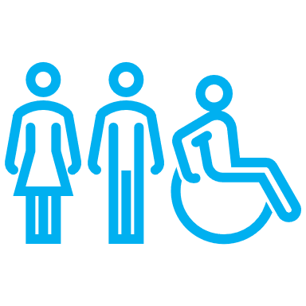Our ageing population and residents with disability need universal access to our social infrastructure*

*Our residents in the west need improved public transport to access social infrastructure*

*Population growth will require new social infrastructure provision*

*We have competing needs from local to metropolitan level, with finite resources*

Our approach

The development of the SIS has been informed by community and stakeholder engagement, detailed analysis of population forecasts, service planning benchmarks and participation trends, forming a systematic needs assessment. A high-level summary of the assessment approach and key insights identified are summarised below:

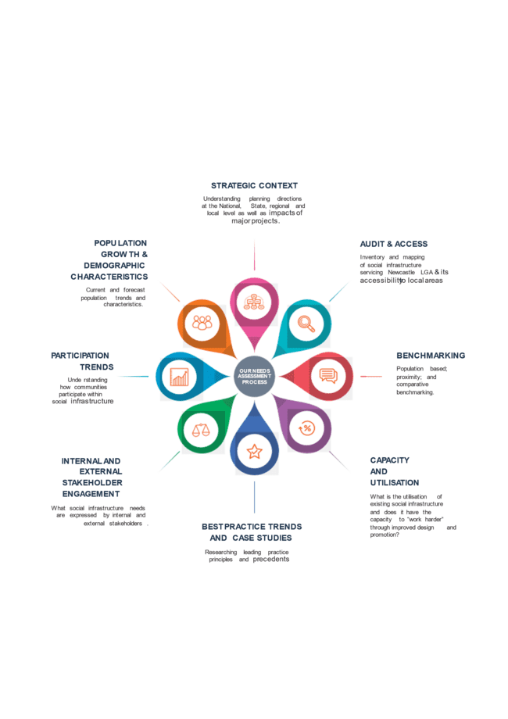

*Considerations*

*Recalibration*

Within the first four years, the plan sets foundational processes and ‘gears up’ for a cultural shift in the provision of SI into the future. Key changes include:

* + Reframing the approach to the delivery of SI by working in a more integrated way through the Integrated Planning and Reporting (IP&R) process
  + Building another layer of evidence through additional planning and economic analysis of community centres and halls, identify a strategic approach to realise a network of co-located hubs of SI.
  + Increasing clarity on how to leverage and manage partnerships for delivery
  + Monitoring the changing approach and role of SI at a federal and state level
* Responding to specific changes to revenue streams, such as Section 7.11 and 7.12, and the ever changing grants landscape.

*Integrated and prioritised*

An integrated approach means collaborating to achieve common goals. For the SIS, this is necessary for the achievement of the strategic priorities over the short, medium and longer term. It requires different levels of government, agencies and organisations to understand the multiple objectives each are trying to achieve and to transparently observe, understand, contribute to, and support one another’s plans.

Integration also means planning and delivering better results, together. Moving from isolated, asset-by-asset or sector-by-sector approach and siloed planning and decision-making. An integrated approach for the SIS, will take the form of increased collaboration within CN and also improved working relationships with key groups and stakeholders for outcomes in our community.

This approach allows us to be more adaptive when assessing priorities for investment. It helps us look beyond the financial implications alone to consider a range of important factors and ensure we are making decisions not just because we can, but because it’s the right thing to do. When considering and prioritising an investment we will use tools and methods that ensure the following questions are considered.

*Funding and delivery*

Although funding of SI has historically been the domain of state and local government, there is an increasing trend across Australia to utilise partnership approaches and other innovative funding contributions to better align infrastructure provision with community needs.

Several funding mechanisms are available to deliver the range of facilities, places and spaces communities require. In addition to the initial capital expenditure required to construct new or expand existing places, spaces, there are additional, often significant costs associated with management of community facilities and assets (such as general upkeep, maintenance and repairs), as well as recurring operational costs relating to resourcing, staffing and service delivery. Planning for community infrastructure often fails to take into account the ongoing costs associated with providing a facility, space or service, and/or an agreed level of community subsidisation which can have a substantial impact on long-term financial sustainability.

CN will leverage a variety of funding and delivery mechanisms to realise better outcomes for the community, both independently and by supporting other stakeholders to do the same. These include:

|  |  |
| --- | --- |
| **Tax outlineState and local government taxes, rates and charges,** which can be used to provide infrastructure that is considered necessary for the effective functioning of society | Safe outline**Annual adopted budgets**, which already allocate funding for social infrastructure purposes including the maintenance, upkeep and upgrade of our existing assets |
| **Dollar outlineFederal and state government grants** in a range of categories, which are made available to communities, local government and NGOs towards the provision of infrastructure and programs | **Handshake outlinePartnerships, sharing or joint ventures**, which can involve a commercial partner gaining rights to develop government-owned land in return for the construction of social or other infrastructure, sometimes associated with a cash payment. Partnerships may also be formed with other Government agencies. |
| **Building Brick Wall outlineDeveloper incentives and contributions**, imposed via strategic plans or conditions of approval, which can be utilised to fund certain components of public space community infrastructure and usually include land, works and/or payments towards the provision of infrastructure | **Signature outlineVoluntary infrastructure agreements** between amenable parties, which can be utilised to provide land, facilities and/or costs associated with the provision of infrastructure |
| **Arrow circle with solid fillAsset recycling** allowing for reinvestment in new or better-fit infrastructure. Strategic assessments and community consultation will allow CN to further consider the usefulness of existing facilities to the communities they serve | **Lightbulb and gear outlineHarnessing opportunity** for community outcomes by applying SIS priorities in decision making processes (eg when unexpected opportunities arise) |
| **Checklist outlineMaking our assets work harder**, taking what we already have and making it work better for our community | **Cheers outlineSupporting our community** to increase access, use and enjoyment of Newcastle's places and spaces. |

# **Our priorities**

***Priority 1* – Equitable distribution for growth and resilience**

***Priority 2* – Quality and adaptive places to play and stay**



***Priority 3* – Community capacity building and inclusion**

***Priority 4* – Governance, partnerships and collaboration**

|  |  |
| --- | --- |
| Priority 1: | Equitable distribution for growth and resilience |

|  |  |  |
| --- | --- | --- |
| **Objectives** |  | * 1. Plan for and support an equitably distributed network of local, district and LGA-wide social infrastructure hubs, building upon local centres hierarchy   2. Prioritise social infrastructure investment in areas with current gaps, forecast urban renewal and population growth, and areas of high socio-economic disadvantage   3. Improve access to and between social infrastructure, through public transport advocacy, blue and green grid and recreational connections |

|  |  |  |
| --- | --- | --- |
| **Indicator** | **Measure by CN/other** | **Data source** |

|  |  |  |
| --- | --- | --- |
| Equitable distribution  Access to SI (distribution and programme related affordability) | Green area (hectare) per planning district as agreed benchmarks  Proportion of community space sqm2 by type per district as agreed benchmarks  (target: trending up)  Overall liveability and wellbeing score for Newcastle  Proportion of user group types  Subjective: Community satisfaction with access to social infrastructure | SIS Audits  SI condition assessments  SIS Audits  SI condition assessments  CN Liveability and Wellbeing Survey  CN booking data  CN Community Satisfaction survey |

|  |  |
| --- | --- |
| **Links to CSP** | 1.1.1 Great spaces  1.2.1 Connected communities  1.2.3 Equitable communities  1.2.4 Healthy communities  1.3.1 Connected cycleways and walking networks  1.3.4 Effective public transport |

|  |  |
| --- | --- |
| **Links to other CN strategies/plans** | * Local Strategic Planning Statement 2020 * Local Housing Strategy 2020 * Fern Bay and North Stockton Strategy 2020 * Strategic Sports Plan 2020 * Parkland and Recreation Strategy 2014 * Newcastle Transport Strategy 2014 * Local Centres Public Domain Strategy |

***Why is this priority important?***

**Social infrastructure builds resilience**

There are three ways communities can build resilience: physical, social and economic. Public places and spaces provide community focal points that can anchor people together, including in times of crisis (e.g. COVID-19 pandemic; floods). The services, programs and activities housed within these public places and spaces connect people and strengthen community resilience.

**Addressing inequitable distribution through new social infrastructure in growing areas**

While some areas of Newcastle currently have good access to SI, others do not. There is a higher provision in the more established East (excluding Stockton) and Central Districts, and less provision in the growing West and North-West Districts. Some of our suburbs (such as Wallsend, Elermore Vale, Maryland, Minmi and Fletcher) require further planning and feasibility assessment to identify ways to make improvements to existing SI which can achieve more for the community and also realise a variety of pathways to respond to the SI requirements needed to service the forecast growth.

Our community told us that more equitable distribution of SI is one of their highest priorities. An absence of SI means that those without access – particularly in more socio-economically and transport-disadvantaged areas such as Minmi, Jesmond and Wallsend – have fewer places to meet, fewer active community organisations, and a lack of connections to quality metropolitan places in our city centre. This can inhibit their capacity to respond to challenges or enable collective action and community resilience.

**Operating as a network**

Best practice trends (including the NSW Government’s *Public Spaces Charter*) show that SI is more commonly being planned to operate as part of a network of public facilities, open spaces, streets and services that work together to meet a broad range of community needs across a neighbourhood or district. This approach avoids duplication and provides a complementary range of offerings. In geographically dispersed areas such as Newcastle, the approach includes the provision of district public facilities in larger strategic centres, with smaller satellite public facilities in local centres providing spaces for outreach services.

An emerging SI network would build upon existing spatial structures and hierarchies such as the hierarchy of local centres and the expected growth corridors. SI exists in these locales at present, and we will build upon what already exists for the benefit of the community.

**Locating our social infrastructure in the right places**

The location of SI is one of the primary determinants of function and usage. Planning SI to maximise community participation means locating it close to public transport and walking/cycling networks in key activity centres for visibility and integrating it with surrounding land uses such as open space and recreation.

The NSW Government has set a priority to increase the proportion of homes in urban areas within 10 minutes’ walk of quality green, open and public spaces by 10% by 2023. Our streets provide the links between these spaces and walking, and cycling are our most popular recreational activities. Improving our blue and green grid and active recreational links will extend and improve the SI network, increasing utilisation of our SI and active transport opportunities.

CN’s integrated approach will capitalise on existing processes such as public domain renewal, land use planning and transport planning processes to ensure SI adds critical mass in urban environments across the city.

Indicative networked social infrastructure in Newcastle

|  |  |
| --- | --- |
| Priority 2: | Quality and adaptive places and spaces |

|  |  |  |
| --- | --- | --- |
| **Objectives** |  | * 1. Improve the capacity, flexibility and amenity of our existing public facilities, parks and open spaces   2. Support public facilities, public parks and open spaces to work harder and adapt to multipurpose and/or co-located places and spaces   3. Champion and progress innovative projects that realise contemporary social infrastructure design, respond to community need and participation trends and harness the benefits of technology |

|  |  |  |
| --- | --- | --- |
| **Indicator** | **Measure by CN/other** | **Output** |

|  |  |  |
| --- | --- | --- |
| Quality of SI (programming, amenities, adaptability, aesthetics, active/passive)  Co-location/ Multifunction | # of our SI achieving embellishment standards framework  # of our SI achieving agreed service planning levels  Subjective: Community satisfaction with quality of SI they access (average out of 100)  Subjective: Satisfaction with our green and blue spaces  Proportion of SI adapted to co-located/multifunctional  # of community hubs | SI condition assessments  CN service planning  CN Community Satisfaction survey  CN Community Satisfaction survey  SIS audit  CN condition assessments  CN asset register |

|  |  |
| --- | --- |
| **Links to CSP** | 1.1.2. Well-designed places  1.4.1 Emerging technologies  2.1.3 Resilient urban and natural areas  1.4.2 Digital inclusion and social Innovation  3.3.2 Promote Newcastle as a major arts and cultural destination |

|  |  |
| --- | --- |
| **Links to other CN strategies/plans** | * Library Strategy 2019 – 2029 * Disability Inclusion Action Plan 2022 - 2026 * Parkland and Recreation Strategy 2014 * Strategic Sports Plan 2020 * Dogs in Open Space Plan 2019 * Draft Service Asset Plans |

***Why is this priority important?***

**Improving the quality and amenity of what we have**

While we need to plan new SI to address growth, we first need to assess potential in what we already have. Where existing SI is well located and has the capacity to become modern, flexible and multipurpose, there may be opportunities for renewal or upgrade. This must be considered in the context of growth and increasing community expectations to improve the capacity, efficiency and performance of our SI as a priority.

When considering renewing or upgrading the quality and capacity of our existing SI, the following four key attributes should be unlocked to achieve a broad range of benefits:

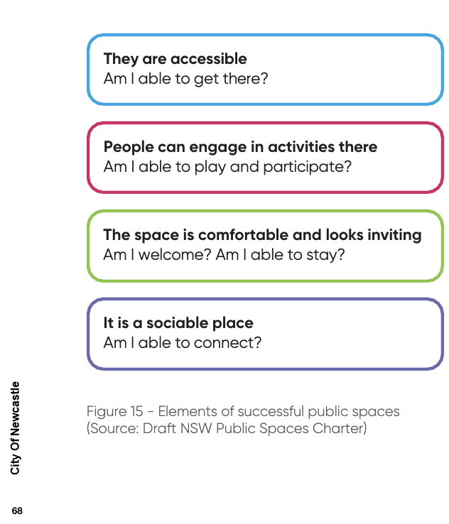

Source – NSW Public Spaces Charter (2021)

Our community told us there are opportunities to improve existing SI. For example, some of our community spaces are not fit out with amenities such as air conditioning, storage for regular hirers or kitchen facilities to increase use and functionality. Ageing, poor-quality and single-purpose assets can be a maintenance burden and are less frequently utilised than quality SI that is fit for purpose. While many of our local community halls/centres are not fit for purpose and need some improvement, they are still reasonably well utilised, indicating that they are important community spaces. Currently, our community centres and halls are small and single-use, and 60% of our libraries are less than 300m2 in size. This limits their ability to be flexible multipurpose spaces and to deliver the kinds of programs and services expected of modern community spaces and libraries.

'Within Newcastle, there is quality open space to enjoy. However, these sport, play and open space areas could be better optimised to 'work harder' for the community.

**Harnessing opportunities**

The SIS framework provides guiding principles for CN to respond to opportunities. On occasion, opportunities with potential community value emerge that are not anticipated or driven by CN’s direct involvement. The SIS framework allows CN and its partners to work through any ‘windfall’ or unforeseen opportunities with SIS principles and priorities at hand. Ongoing evidence-gathering, consultation and data analysis similarly builds CN’s capacity to respond.

**Co-located and multifunctional spaces**

'Co-locating' our SI and creating more multipurpose spaces for a range of activities will increase capacity and create a more economically, environmentally and socially sustainable networks. Multipurpose facilities can be adapted as community needs and interests change and co-locating a range of uses in one space reduces the floor space and maintenance required. New models such as stacked buildings and mixed-used developments, will be explored as opportunities for SI. This responds to the increasing density in our city, where land values are high and land is scarce.

Co-location can take a number of forms, including models where multiple, independent, services are accommodated under the one roof; shared accommodation, service and administration models; and precinct or campus style developments, where multiple services are located in separate accommodation within the one, common, site. The image below, provides an indication of the opportunities for savings in scale, measured in Gross Floor Area (GFA), that can be gained through co-location of both ‘foundation’ and ‘supporting’ SI. This includes the co-location of leisure and recreation places and spaces with community and cultural facilities, as well as the inclusion of spaces for groups that historically occupy separate facilities (for example seniors, youth) within multi-purpose community hubs.

**Maximised contribution of new technologies and sustainability treatments**

Community facilities should be planned to maximise the contribution of new technologies, including those supporting service delivery, creative industries, learning and community-building. Examples such as Wi-Fi accessibility should be considered as part of the infrastructure’s design. Digital technology can also assist in capturing and sharing data to help inform decision-making associated with the performance, design, planning and delivery of SI.

Similarly, projects for new SI or asset renewal should reflect sustainability principles to ensure efficient and low impact operations. When planning new assets or renewal, CN applies a range of sustainability principles to ensure efficient and low impact operations, consistent with our climate action goals

**Intergenerational spaces**

Community engagement results indicate a need for more spaces that support intergenerational use (e.g. adventure play for families with children, places for parents to sit and chat, places for young people to hang out and places for seniors to exercise), as well as more spaces for informal and unstructured social and recreational activities (such as multipurpose courts, rebound walls and gathering spaces).



|  |  |
| --- | --- |
| Priority 3: | Community capacity-building and inclusion |

|  |  |  |
| --- | --- | --- |
| **Objectives** |  | 3.1 Ensure equitable and transparent fees alongside sustainable revenue streams  3.2 Inclusive and welcoming social infrastructure designed, managed and programmed for all in our diverse community to enjoy  3.3 Enhance social connections, community participation and capacity building facilitated through our social infrastructure  3.4 Continue to engage with our communities around their social infrastructure needs and inform and involve them in decision making |
|  |  |  |

|  |  |  |
| --- | --- | --- |
| **Indicator** | **Measure by CN/other** | **Output** |

|  |  |  |
| --- | --- | --- |
| Community capacity building and inclusion  Fees and charges affordability  Community engagement | Subjective: Perceptions of feeling part of local community and that Newcastle is welcoming of diversity  Proportion of user group types (community rate verses corporate rate)  # of people engaged around their SI needs  Subjective: Do you feel there are opportunities to have a real say on SI projects that are important to you? | CN satisfaction survey  CN booking data  CN data  CN Community Satisfaction Survey |

|  |  |
| --- | --- |
| **Links to CSP** | * 1.2.1 Connected communities * 1.2.2 Inclusive communities * 1.2.3 Equitable communities * 1.2.4 Healthy communities * 1.4.2 Digital inclusion and social innovation * 3.3.1 Nurture cultural and creative practitioners * 3.3.3 Culture in everyday life * 4.2.1 Genuine engagement |

|  |  |
| --- | --- |
| **Links to other CN strategies/plans** | * Draft Local Social Strategy * Disability Inclusion Action Plan 2022 – 2026 * Reconciliation Action Plan 2021 - 2024 |

***Why is this priority important?***

Great SI is accessible to all people in the community. It can help all people feel welcome and connected, providing opportunities to meet with neighbours, family and friends. The 2021 *NSW Public Spaces Charter* prioritises public spaces as free, open and welcoming for people of all ages, genders, backgrounds and abilities to use and enjoy. But for Newcastle, there is increasing evidence that while social and economic disadvantage increases, participation in community programs decreases, with some of our residents having less money to spend and others being unable to access what they need.

**Genuine engagement**

CN has a strong commitment to involving our community in decision making through genuine engagement and informing our community about CN programs, services and projects, the SIS will continue this commitment.

**Responding to diversity**

Our community is diverse, with different groups needing different programs and services and having different abilities to access what they need. CN through the SIS and Local Social Strategy sets a road map for ensuring that diversity and difference is celebrated and respected, and that diverse communities have equal opportunities to access our places and spaces in ways important to them.

**Transparent user fees and charges**

Transparent, fair and consistent fees and charges for our SI is important to enable community groups to deliver programs and services independently.

The availability of free, informal SI for the community to access informally is particularly important in the more socially and economically disadvantaged areas of Wallsend, Elermore Vale, Minmi and Jesmond, including exercise equipment, walking paths, community gardens, play spaces, active youth hubs and multipurpose courts.

**Accessible, inclusive places and spaces**

While we may have an abundance of natural areas, for ageing residents and people with disability, these may be difficult to access. We need to consider how we universally design our public spaces to include everyone. Local services also told us that improvements are needed to the support infrastructure connecting to our public facilities and open spaces, including our beaches (e.g. footpaths, parking, ramps, paths from bus stops all the way to local centres, etc.).

The SI is directly linked with CN's Disability and Inclusion Access Plan (2022-2026) which aims to increase and improve accessibility of public spaces and to embed inclusion and accessibility principles in our planning. A focus area for the SIS is improving access or connections between our public facilities and open spaces, including our beaches (e.g. parking, ramps, and paths between bus stops and local centres).

|  |  |
| --- | --- |
| Priority 4: | Governance, partnerships, and advocacy |

|  |  |  |
| --- | --- | --- |
| **Objectives** |  | 4.1 Integrate planning, governance and decision making to better align social infrastructure investment with evidence-based needs and prioritisation and support delivery though diverse and sustainable revenue streams  4.2 Improve social infrastructure data capture and technology systems, aimed at increasing user experience, utilisation and organisational insights  4.3 Pursue diverse funding and partnerships to share opportunity and support delivery  4.4 Champion support for our current and projected social infrastructure needs to positively influence decisions within political, economic, and social spheres |

|  |  |  |
| --- | --- | --- |
| **Indicator** | **Measure by CN/other** | **Output** |

|  |  |  |
| --- | --- | --- |
| Integrated SI provision  Data insights  Diverse funding and partnerships | Establish common principles for place-based, cross-agency SI provision  Establish an internal SI governance framework and embed 6 monthly reporting to the Liveable Cities Advisory Committee.  Increase CN-owned SI capacity and utilisation data capture  CN GIS capacity leveraged ongoing SI planning spatial analysis and modelling  Partnership toolkit created  # and value of diverse funding  # of partnerships | CN booking software  CN SI condition assessments  CN data |

|  |  |
| --- | --- |
| **Links to CSP** | * 3.4.2 Government relations and advocacy * 4.1.1 Financial sustainability * 4.1.2 Integrated planning and reporting * 4.2.1 Genuine engagement * 4.3.3. Data innovation and insight |

|  |  |
| --- | --- |
| **Links to other City of Newcastle strategies/plans** | * + Section 7.11 and 7.12 Development Contributions Plan 2022   + Service Asset Plans |

***Why is this priority important?***

**Governance and culture**

Supported by a governance framework to oversee the Strategy’s implementation, we will move towards a new way of thinking about SI, transforming our skills, capabilities and culture around sustainable, integrated SI provision.

Delivering great SI requires the expertise and assistance of many within CN. We know there is still significant work to be done to reach the best possible outcomes for our community in terms of evidence-based needs, resource sharing and prioritisation. We will collaborate within our organisation to prioritise what we need, and with our external partners in the planning, delivery and management of SI. These partners include all levels of government (federal, state and local), industry, NGOs and the private sector, who all play a role.

Throughout the life of the action plan, twice yearly progress reports will be provided to the Liveable Cities Advisory Committee.

**Data insights and system improvements**

Through improved data capture and system improvements, we aim to enhance CN’s capacity and capability around long-term service and infrastructure planning. Investment in systems and data to improve our knowledge and insights about SI will lead to more targeted investments, greater value and outcomes.

**Partnerships and advocacy**

Meeting community needs and aspirations for our city's SI will require a whole-of-community and whole-of-government response involving coordination, cooperation, and partnership between each level of government, community sector and industry to address unmet need and alleviate pressure on existing services and infrastructure. Partnerships and advocacy are critical to achieving the Strategy’s priorities and actions and moving towards new models that service the needs of our community fairly and viably.

# Appendix

## Appendix 1 – Action Plan

*Action from other CN adopted strategies and plans

|  |  |  |  |  |
| --- | --- | --- | --- | --- |
| **Priority 1. Equitable distribution for growth and resilience** | | | | |
| **Objective** | **Action** | **Timeframe** | **Responsibility** | **CSP Priority** |
| **1.1 Plan for and support an equitably distributed network of local, district and LGA-wide social infrastructure hubs, building upon local centres hierarchy** | 1.1.1 Prepare a Community Hubs Strategic Plan | Year 1-2 | Strategy and Engagement  Infrastructure and Property, City Wide Services | 1.2.1, 1.2.3 |
| *1.1.2 Ensure planning for new public open spaces includes provision for improved links to existing park infrastructure or addresses new infrastructure requirements as a result of high future growth areas. | Ongoing – Our Budget | Parks and Recreation | 1.1.1, 1.2.4 |
| *1.1.3 Prepare a Play Spaces Action Plan to guide planning and delivery of a diverse network of play spaces across the LGA | Year 3-5 | Parks and Recreation | 1.1.1, 1.2.4 |
| *1.1.4 Continue to implement the Outdoor Exercise Facility Action Plan 2018 | Ongoing – Our Budget | Parks and Recreation | 1.2.4 |
| *1.1.5 Continue to implement the Dogs in Open Space Plan 2019 | Ongoing - Our Budget | Parks and Recreation | 1.1.1 |
| **1.2 Prioritise social infrastructure investment in areas with current gaps, high socio-economic disadvantage and forecast population growth** | 1.2.1 Continue to negotiate for social infrastructure provision in the land use planning system, specifically in the West District, and in urban renewal corridors and urban release areas such as Wallsend and Minmi | Ongoing - Our Budget | Governance  City Wide Services  Strategy and Engagement | 1.2.3 |
| *1.2.2 Plan the delivery of new sports fields, court surfaces and parks to meet the needs of the growing population in the West District. | Ongoing – Our Budget | Parks and Recreation | 1.1.1, 1.2.3, 1.2.4 |
| *1.2.3 Investigate the provision of a temporary/pop-up community space for a library kiosk in the West District. . | Year 1-2 | Libraries and Learning | 1.2.3, 3.3.3 |
| 1.2.4 Advocate for Social Infrastructure outcomes in the planning and design of the Broadmeadow Place Strategy and Hunter Park, Broadmeadow, including investigation of sport, recreation, community and cultural places and spaces | Ongoing | Governance  City Wide Services Strategy and Engagement | 1.1.1, 1.2.1, 1.3.4, 3.3.3 |
| *1.2.5 Work with State Government to plan for a new regional level competition aquatic centre including social infrastructure to service local community needs | Ongoing | Parks and Recreation | 1.2.4 |
| **1.3 Improve access to and between social infrastructure, through public transport advocacy and blue/green grid recreational connections.** | 1.3.1 Undertake public and active transport analysis to support planning (and advocacy) and enhanced connections to LGA social infrastructure. | Ongoing | Governance Strategy and Engagement | 1.3.1, 1.3.4 |
| 1.3.2 Continue to plan for the long-term delivery of a blue-green-grid network of improved walking and cycling connections to District and Regional level parks, natural areas, and Newcastle's beaches. | Ongoing | Governance | 1.3.1 |
| **Priority 2. Quality and adaptive places and spaces** | | | | |
| **Objective** | **Action** | **Timeframe** | **Responsibility** | **CSP Priority** |
| **2.1 Improve the amenity of our public facilities and open spaces for increased utilisation** | 2.1.1 Complete condition assessment reports for CN-owned social infrastructure buildings | Year 1 -2 | Infrastructure and Property  City Wide Services | 1.1.2, 1.2.3, 1.4.1, 2.1.3 |
| 2.1.2 Develop and implement a tiered embellishment standards framework for all local, district, LGA/metropolitan level community centres/halls, and sport, parks and recreation places and spaces | Year 3 -5 | City Wide Services  Strategy and Engagement  Infrastructure and Property | 1.1.1. |
| *2.1.3 Continue to implement CN Disability Inclusion Action Plan 2022 actions 7 and 11 of continuous access improvement upgrades to CN-owned places and spaces | Ongoing – Our Budget | Infrastructure and Property  City Wide Services | 1.2.3 |
| **2.2 Improve our public facilities and open space as quality multi-purpose and co-located central hubs** | *2.2.1 Prepare masterplans for Newcastle's District and Metropolitan level parks to function as multi-purpose co-located spaces that include community facilities and amenities to support intergenerational, informal and formal uses. | Ongoing – Our Budget | Parks and Recreation | 1.1.1, 1.3.1, 2.1.3, |
| *2.2.3 Investigate opportunities to activate Wheeler Place as an extension of Civic Theatre and City Hall through cultural programming | Year 1-2 | Civic Services | 1.1.1, 3.1.1, 3.1.3, 3.3.1 |
| **2.3 Champion innovative projects that realise contemporary social infrastructure design, utilisation and management** | *2.3.1 Investigate opportunities in West District for a new district-level multi-purpose leisure centre. | Year 1-2 | Parks and Recreation | 1.1.1, 1.2.4 |
| 2.3.2 Create a suite of resources to demonstrate innovative and contemporary social infrastructure to aid land use planning, concept design and delivery of projects | Year 1-2 | Strategy and Engagement | 1.2.1, 1.2.3, 1.2.4 |
| 2.3.3 Contribute to social infrastructure provision through innovative energy efficient products and technologies and integrated solutions that minimise environmental impact | Ongoing – Our Budget | Strategy and Engagement | 2.1.1 |

|  |  |  |  |  |
| --- | --- | --- | --- | --- |
| **Priority 3. Community capacity-building and inclusion** | | | | |
| **Objective** | **Action** | **Timeframe** | **Responsibility** | **CSP Priority** |
| **3.1 Ensure equitable and transparent fees, charges alongside sustainable revenue streams** | 3.1.1 Review CN fees and charges for public places and spaces hire. | Year 1 -2 | Strategy and Engagement Governance  City Wide Services | 1.2.3, 4.1.1, 4.2.3 |
| 3.1.2 Investigate opportunities at CN Newcastle Venues for increased local level community and cultural participation. | Year 3 -5 | Civic Services | 1.2.3, 3.3.1, 3.3.3 |
| **3.2 Inclusive and welcoming social infrastructure managed and programmed for everyone in our diverse community to enjoy** | 3.2.1 Increase awareness of how to book CN community centres and halls | Year 1-2, Year 3 -5, Year 3-5 | Civic Services, Library Services, Strategy and Engagement | 1.2.1, 1.2.3, 1.2.4, 4.2.1, 4.2.3 |
| 3.2.2 Facilitate increased delivery of community support programming in CN community hubs, centres and halls, prioritised in areas of high socio-economic disadvantage and forecast population growth, and in line with management agreements (needs prioritisation through Local Social evidence base). | Year 3 -5, | Strategy and Engagement | 1.2.1, 1.2.2, 1.2.3, 1.2.4 |
| **3.3 Enhance community capacity and social capital facilitated through our social infrastructure** | 3.3.1 Collaborate with our Aboriginal communities to plan for culturally appropriate gathering and connection spaces that can be enhanced/established | Ongoing - Our Budget | Strategy and Engagement | Reported against Local Social |

|  |  |  |  |  |
| --- | --- | --- | --- | --- |
| **Priority 4. Governance, partnerships and advocacy** | | | | |
| **Objective** | **Action** | **Timeframe** | **Responsibility** | **CSP Priority** |
| **4.1 Integrate planning, governance and decision making to better align SI investment with evidence-based needs and prioritisation delivered though diverse and sustainable revenue streams** | 4.1.1 Update the CN Community Assets and Open Space (CAOS) Policy 2017 to align with the strategy principles, hierarchy recommendations and functional guidance. | Year 1 -2 | Strategy and Engagement | 4.3.1 |
| 4.1.2 Report annually on SIS progress to the CN Liveable Cities Advisory Committee | Ongoing – Our Budget | Strategy and Engagement | 4.1.2 |
| 4.1.3 Continue to work with NSW emergency services around utilisation of CN-owned social infrastructure in crisis events such as natural disasters | Ongoing – Our Budget | Governance, Strategy and Engagement | 2.1.3, 4.2.3, 4.3.1 |
| 4.1.4 Review and update community centre and halls management agreements to enable positive outcomes for local communities and disadvantaged groups | Year 1 | Infrastructure and Property | 4.3.1 |
| **4.2 Improve social infrastructure data capture and technology systems, aimed at increasing user experience, utilisation and organisational insights** | 4.2.1 Develop and implement data systems and analytic framework for CN-owned social infrastructure to monitor and improve capacity, utilisation and community benefit | Year 3 -5 | Strategy and Engagement | 4.3.2, 4.3.3 |
| 4.2.2 Leverage CN GIS to support ongoing spatial analysis and modelling (eg site analysis, transport modelling) to underpin social infrastructure planning. | Year 1 -2 | Strategy and Engagement | 4.3.3 |
| **4.3 Pursue diverse funding and partnerships to share opportunity and support delivery** | 4.3.1 Prepare a prospectus of social infrastructure opportunities and demonstrate CN’s readiness for partnerships and shared uses | Year 3 -5 | Strategy and Engagement | 4.3.1 |
| 4.3.2 In line with the asset planning framework, facilitate grant readiness program (eg program of concept design ready projects). | Year 3 -5 | Strategy and Engagement  Parks and Recreation  Library Services Museum  Civic Services Governance Infrastructure and Property | 4.1.2, 4.3.2 |
| 4.3.3 Develop and implement a tool kit for use by CN Staff leveraging and maintaining successful partnerships. | Year 3 -5 | Strategy and Engagement | 4.3.1, 4.3.2 |
| 4.3.4 Investigate opportunities to increase access to non-Council owned community spaces for public use through shared and joint use arrangements and agreements and equitable fees and charges | Year 1-2, Year 3 -5, | Strategy and Engagement  City Wide Services | 4.3.1 |
| **4.4 Advocate for our current and projected social infrastructure needs to positively influence decisions within all political, economic, and social spheres** | 4.4.1 Prepare an advocacy roadmap which sets a strategic approach to social infrastructure advocacy for the city | Annually – Our Budget | Strategy and Engagement | 3.4.2 |

## Appendix 2 – Catchment Planning and Demographics

The SIS takes a catchment approach to the assessment and planning of SI. This approach aims to reflect, where possible, patterns of community preference in accessing services and facilities, along with groupings of planning catchments that are socially and geographically aligned. (For example, best practice library provision indicates that local government should seek to develop larger district facilities and, as a result, serve the needs of a catchment area larger than one or 2 suburbs.)

The Strategy’s catchments are based on the following SI hierarchy, with the lowest-level planning catchments aligning with other CN strategies and land use hierarchies (including the *Newcastle Local Housing Strategy and Local Centres Hierarchy’*). Planning catchments utilise the Australian Statistical Geography Standard Statistical Area Level 2 (SA2, one to 2 suburbs, average of about 10,000 people) functional areas.

When combined with standards of provision and population-based benchmarks, the SI hierarchy enables assessment of comparative under-supply or over-supply of social

infrastructure. Various provision standards and benchmarks were employed when determining catchments’ future needs and potential gaps related to SI. Population-based benchmarks were used to give an indication of the number and size of items of SI that will ideally be provided if opportunity exists. Many of the SIS standards of provision rates and benchmarks are well accepted as industry standards.

NB: SI in adjoining areas outside Newcastle was also included in the assessment. The SIS aims to ensure that all planning catchments have access to local-level SI at a minimum.

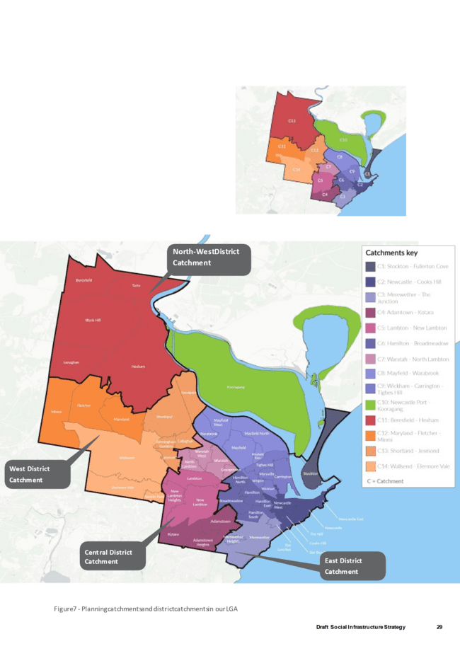

Planning catchments and district t catchments in our LGA

***What social infrastructure do the demographics indicate is needed?***

***Increasing residential population***

Rapid growth areas such as Maryland–Fletcher–Minmi, Newcastle–Cooks Hill and Mayfield–Warabrook and increasing density in areas such as Newcastle City Centre, Mayfield (Maitland Road), and around the Broadmeadow, Adamstown and Hamilton Stations is increasing demand for ‘third spaces and open space that functions as a ‘backyard’ for apartment residents.

***Socially and economically disadvantaged residents***

There is significant disparity in relation to social and economic disadvantage across the LGA, with the West and North-West Districts’ planning and growth considering concentrations of highly disadvantaged areas (Shortland, Birmingham Gardens, Wallsend, Jesmond) and how they can benefit through quality SI. People living in these areas have poorer outcomes for their older residents (on the Index of Wellbeing of Older Australians [IWOA]), higher proportions of residents needing assistance, lower internet access, higher unemployment and higher proportions of children and young people. Barriers to participation for lower socio-economic groups may include cost, lack of time or transport access. Ensuring SI is affordable, accessible and in proximity to public transport will support participation.

***Aboriginal and Torres Strait Islander communities***

In 2016, 3.5% of the total Newcastle population identified as being Aboriginal and Torres Strait Islander (NSW=2.5%). The Awabakal and Worimi peoples are the traditional custodians of the land and waters of the Newcastle LGA. Future planning for the LGA can recognise, celebrate and learn from Aboriginal connection to Country within the design and activation of SI (particularly open space and cultural facilities), especially in areas with higher-than-average aboriginal populations such as Carrington, Maryland and Beresfield–Tarro.

***Culturally and linguistically diverse people***

While Newcastle has a relatively low proportion of residents from non-English-speaking backgrounds, there have been increasing numbers of residents from overseas, particularly in areas such as Jesmond (a high of 38% in 2016), Birmingham Gardens–Callaghan (likely university students), Warabrook and New Lambton. The top emerging non-English languages were Chinese languages, Malayalam, Persian/Dari and Vietnamese. SI can facilitate cross-cultural relationships and new connections for recently arrived residents, as well as access to Settlement Services and English language classes. Culturally diverse residents may also have a range of cultural and recreational interests that SI should respond to, including demand for activities such as badminton, swimming, outdoor ping pong, dancing and walking in the evenings. We also know that indoor recreational facilities and courts are in higher demand from culturally diverse communities.

***Living with disability***

In 2016, 9,197 people (or 5.9% of the population; NSW=5.4%) in Newcastle had a ‘*profound or severe disability',* defined as people “needing help or assistance in one or more of the three core activity areas of self-care, mobility and communication, because of a disability, long term health condition (lasting six months or more) or old age”. While Newcastle and NSW have similar proportions of residents reporting a need for assistance with day-to-day activities, some planning catchments of the LGA have higher populations of people in need of assistance, including Shortland–Sandgate, Wallsend, Jesmond and Warabrook. Universally accessible and inclusive public spaces should be a priority across the LGA, but there is also a need to consider social programs and services that are accessible to people living with disability located in areas with high need.

***Young people and workforce/students***

We have a high population of young people, including students and young workforce-aged residents, and our community has prioritised a need for libraries and parks, leisure centres and recreation facilities, and more spaces (particularly free spaces) that support intergenerational use (e.g. adventure play for families with children; places for parents to sit and chat; formal and informal places for young people to hang out).

***Children and families***

Newcastle has a similar proportion of children to regional NSW but showed an increasing number of family households between 2011 and 2016. In some areas such as North Lambton, Beresfield–Tarro, Maryland and Tighes Hill, there are higher proportions of one-parent families. Children and families need access to quality early education and care services (including long day care, preschool and out-of-school-hours care), primary school, and school holiday programs including arts, cultural, technological and recreational programs. Children and families need access to open space and recreation facilities for play, exercise and relaxation. Future planning should consider the needs of families with children, including: open spaces that can host celebrations; accessible facilities located near public transport or parking; accessible play spaces suitable for different ages and abilities; and dedicated parents’ rooms in public amenities. Australian Early Development Census data also tells us that in some parts of the LGA, there are higher-than-average proportions of children who are developmentally vulnerable, with particularly high numbers in Jesmond, Waratah, Beresfield, Hamilton and Hamilton East indicating a need for access to high-quality early education and care as well as family support services in these areas.

***Diverse genders and sexualities***

Lesbian, Gay, Bisexual, Transgender, Queer, Intersex and Asexual (LGBTQIA+) people and communities represent a diverse and often underrepresented population. They are estimated to be between 4,000–15,000 people in Newcastle (*Social Strategy 2016–2019*). This community needs access to safe spaces to connect, but also access to support services.

***Homelessness and risk of homelessness***

Homelessness in Australia remains a significant issue. On Census night in 2016, an estimated 116,427 people were staying in temporary or emergency accommodation or in severely overcrowded dwellings, or ‘sleeping rough’ (ABS 2018). This translates to a national homelessness rate of 50 persons for every 10,000 enumerated in 2016, a rise (5%) from 48 persons in 2011 and 45 persons in 2006 (ABS 2018). From a SI perspective, people sleeping rough or at risk of homelessness need access to social welfare services, safe and accessible amenities (showers, toilets, laundry facilities), air-conditioned spaces during extreme heat events, and places and spaces in our city that are welcoming for all.

***Older people***

Newcastle is an area of families, but also has an ageing population. Between 2011 and 2016, the population aged 65+ grew by 20% and is forecast to increase by more than 30% by 2041. Areas such as Beresfield–Tarro, Merewether Heights, Rankin Park, Warabrook and Waratah have the highest proportions of older people in the LGA. Participation in social, cultural and recreation activities bring many benefits as people age, including improved health and wellbeing and social connection. There will be increased need for SI that supports activities for older people, such as creative and performing arts participation and viewing, gentle exercise (e.g. swimming and walking), and access to libraries and lifelong learning.

SI should also be universally designed so it is accessible as people become frailer. Accessible connections to local parks and services are also important. The IWOA also indicates that there are significantly low wellbeing levels in several planning catchments; older people in these areas will need access to social services and programs, including social outings, meals and Home and Community Care services.

## Appendix 3 – What our community told us

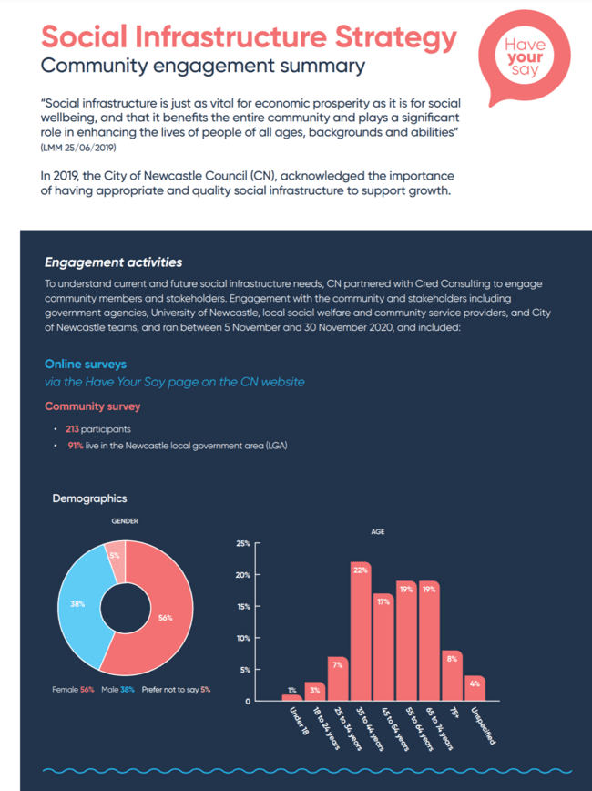

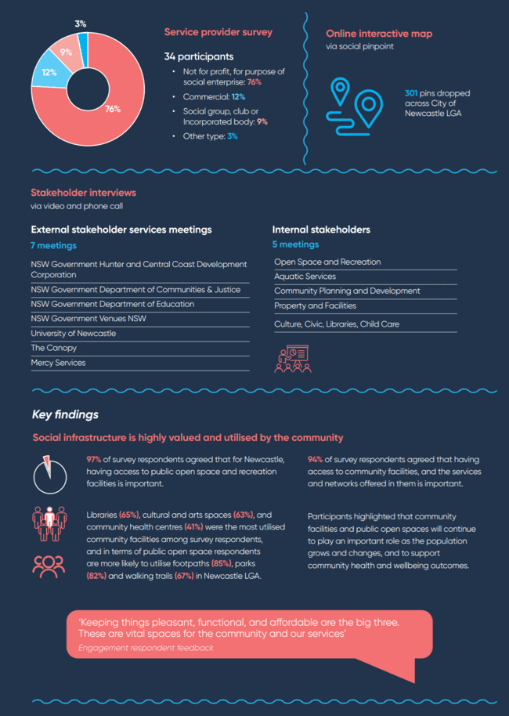

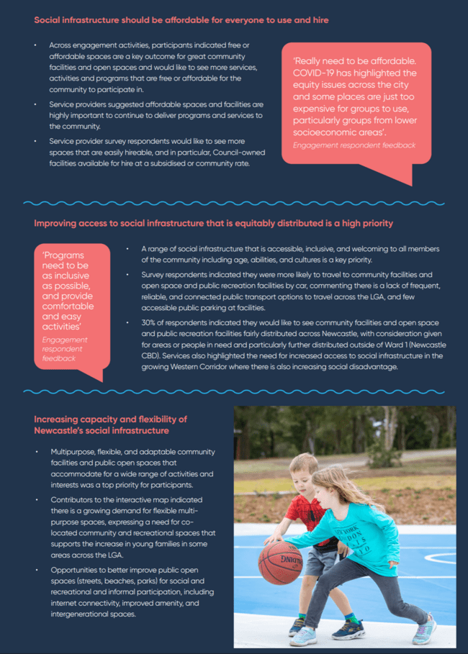

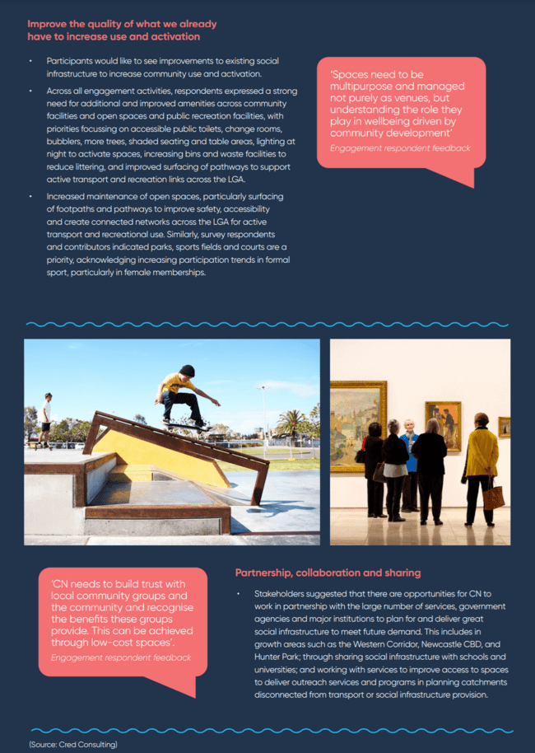

1.