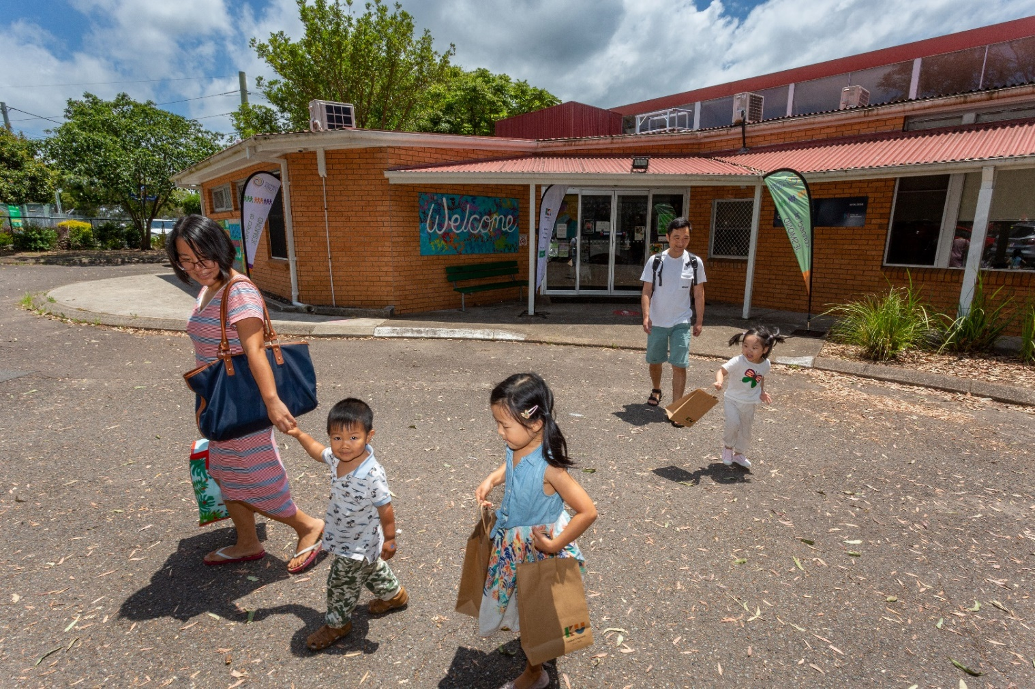
Image 1: Jesmond Neighbourhood Centre, Jesmond

Social Infrastructure Strategy
Public Exhibition Engagement report

January 2023
Prepared by: Media Engagement Economy & Corporate Affairs
Enquiries: engage@ncc.nsw.gov.au or (02) 4974 2000
Table of contents

Executive summary 3
1. Background 5
2 Engagement objectives 5
2. Communication and promotion 5
3. Engagement activities 7
4. Key findings 8
5. Final take outs 18
6. Recommended amendments to draft Strategy based on key themes from public exhibition 18
Appendix 1 – Promotional materials 21
Appendix 2 – Online feedback form 24
Appendix 3 – Other submissions 29
Appendix 4 – Workshops and events notes / feedback 37

Executive summary
Newcastle is experiencing significant growth in our population, economy and liveability.
The draft Social Infrastructure (SIS) Strategy is a ten-year visioning document which will play a critical role in guiding the city's public community spaces, places and facilities (social infrastructure) network now and into the future. They are our parks and bushland reserves, beaches and swimming centres, museum and gallery, and libraries and community centres. The city's public places and spaces that form the heart of our communities are at the centre of the new Social Infrastructure Strategy.

For the SIS's initial conceptualisation and development, including a needs assessment, stakeholder and community engagement was undertaken in 2020 and 2021. To help finalise the draft document, CN also sought refinement feedback from the community and stakeholders via public exhibition of the draft SIS from 28 September to 25 November 2022.

The public exhibition engagement objectives included gaining a better understanding of community and stakeholder opinion on the draft SIS, such as what they like about the draft and what could be improved; generating conversation about the value to the city of our social infrastructure and the many ways they contribute to Newcastle's economic and social wellbeing; and strengthen relationships with relevant community groups and key stakeholders to guide the implementation of the strategy and partnerships for delivery of our public places and spaces (social infrastructure).

During the public exhibition, a variety of communications and promotion activities were deployed to raise awareness of the SIS and promote the opportunity for community members to provide feedback. Key communications activities included a dedicated Have Your Say Page, post card style hand outs and static displays, emails to key stakeholders, social media posts, newsletters and a media release. In total there were 22 submissions through a City of Newcastle (CN) online form and email, and approximately 300 community members and stakeholders engaged at 15 exhibition events and workshops.

For the online options, the community were invited to provide feedback on the draft SIS through the online open feedback form, or alternatively by mail, email or phone. The online submissions revealed general support of the Strategy, with 68% of respondents agreeing with the four priorities and offering suggestions for improvement rather than disagreeing with the strategy overall. The feedback for areas that were liked and areas that could be improved to the draft strategy and implementation, were broken into key themes/topics.

Items supported in the draft SIS included:
- The priorities, drivers of change and action plan,
- Social infrastructure to support families, children and young people,
- Health and wellbeing.

Items suggested for refinement in the draft SIS included:
- Greater utilisation, upgrade and management of existing places and spaces,
- More partnership and funding pursued,
- Between and to social infrastructure, improved connectivity and public/active transport,
- Other suggestions included accessibility and (un)affordability of CN social infrastructure, equitable distribution of SI across whole of city, CN community engagement and supporting communications, and climate adaptation/sustainability.

Community members and key stakeholder were also able to provide feedback through one of the
15 stakeholder and community events and workshops that ran over the public exhibition period by the CN Community Planning and Development Team. Collectively, approximately 300 community members and stakeholders attended these events and stakeholder workshops. The documented conversations and feedback from these workshops were also analysed and discussed in the following. From the feedback captured at these sessions, five key themes were identified, including suggestions on how to improve public places and spaces more broadly and how CN could facilitate this within the Strategy’s scope.

The themes identified included:
• Spaces and places – multiuse, utilisation and intergenerational,
• Spaces and places – inclusive, accessible and affordable,
• Local government roles, responsibilities, remit and advocacy,
• Community and stakeholder engagement and collaboration.

As a result of public exhibition some changes have been made to the draft SIS reflecting community comment, and the amended draft SIS will be presented to the Council for consideration of adoption. A summary of changes is included in Section 6. Recommended amendments to draft Strategy based on key themes from public exhibition.

Background
Newcastle is experiencing significant growth in our population, economy and liveability.
The draft Social Infrastructure (SIS) Strategy is a ten-year visioning document which will play a critical role in guiding the city's public community spaces, places and facilities (social infrastructure) network now and into the future. They are our parks and bushland reserves, beaches and swimming centres, sport fields, museum and gallery, and libraries and community centres. They are where connections are made, where we learn and grow, and where we stay active and healthy. The city's places and spaces that form the heart of our communities and bring our people together are at the centre of the new Social Infrastructure Strategy.
In 2020 and 2021, City of Newcastle (CN) undertook community and stakeholder engagement, along with grounding research and needs assessments to conceptualise and develop the draft document. To help finalise the draft Strategy, CN sought feedback from the community and stakeholders via public exhibition ahead of sending the final Strategy to Council for adoption in early 2023.
This report outlines the SIS public exhibition engagement activities that were undertaken from
28 September to 25 November 2022.

2 Engagement objectives
To better understand community and stakeholder opinion on the draft SIS, CN publicly displayed the Strategy from 28 September to 25 November 2022.
More specifically, the public exhibition sought to:
- Gain refining feedback from the community and relevant stakeholders.
- Generate conversation about the value to the city of our social infrastructure and the many ways they contribute to Newcastle's economic and social wellbeing.
- Strengthen relationships with relevant community groups and key stakeholders to guide the implementation of the strategy and partnerships for delivery of our public places and spaces (social infrastructure).

Communication and promotion
During the public exhibition, a communications campaign was implemented, including a QR code photography competition to raise awareness of the draft SIS and promote the opportunity for community members to provide feedback.
Key communications activities are summarised on the following page, and key pieces of communications collateral are available in Appendix 1.

Channel | Description | Reach
Have Your Say webpage | A dedicated project webpage was created on CN’s Have Your Say landing page. A link to this page was also added to CN’s Public Exhibitions page. The page aimed to provide information and raise awareness about the draft SIS and direct people to the online feedback form. | 3,781 page visits
Post card and static displays | A post card style hand out was designed to be distributed at events and workshops that took place in the public exhibition period.  To support this, static displays with information about the proposed SIS were displayed at community centres and libraries across the city. | 500 post cards distributed  15 onsite locations
'  Stakeholder emails | Information about the draft SIS was emailed to subscribers of the Community Planning & Development community admin newsletter, community members who requested to stay informed about SIS updates and community development stakeholders. | Distributed to 1,145 subscribers
Social media | The public exhibition was promoted via a paid post of CN’s Facebook and LinkedIn pages. The posts intended to raise awareness and encourage community members and relevant stakeholders to have their say. | 17,592 reached  213 engagements  1055 clicks
Newsletters | Information about the draft SIS was published in two of the dedicated Have Yours Say monthly e-newsletters. | Distributed to 2,439 subscribers
Media | A media release with information about the draft SIS was issued on 10 October 2022 | n/a

Engagement activities
The community were invited to provide feedback on the draft SIS from 28 September to 25 November 2022.
The community were able to provide comment on the SIS in a number of ways:

Feedback form
A link to the guided online feedback form was provided on the dedicated SiS Have Your Say page. The Have Your Say page provided the Strategy to view in several formats, including a summary version that was embedded into the form for reference. The guided form, including single choice, and open-ended questions asked participants the following questions:
- Do you agree with the four priorities of the draft Strategy?
- What parts of the draft Strategy do you like?
- What parts of the Strategy could be improved?
- Do you have any additional comments about the draft Social Infrastructure Strategy?
In total, 19 people provided feedback via the feedback form. Findings from the online form are presented in section 4. Key findings. Verbatim comments and feedback can be found in Appendix 2.
Other submissions
Community members were also able to provide feedback on the SIS by mail, email or phone. In total, three submissions were received via these channels. De-identified copies of the submissions received is included in Appendix 3.
External stakeholder consultation, committee meetings and workshops
Additionally, the Community Planning and Development team (CP&D) organised and attended a variety of events and workshops to promote the draft Strategy and seek feedback. The team met with approximately 290 community members and advocates to raise awareness of the Strategy and ask for feedback. The events included:
- Guraki Advisory Committee Meeting, Awabakal Local Aboriginal Land Council (26 September 2022),
- 42nd Hamilton South Hall celebration, Hamilton South (28 September 2022),
- Newcastle Youth Council presentation, CN City Library (5 October 2022),
- Drop-in sessions at Hope Street, Baptist Care (12 October, 13 October, and 19 October 2022),
- Diverse Genders and Sexuality Community session, Lambton Park Hotel (17 October 2022),
- Hunter Ageing Alliance Morning Tea & Learn, CN Digital Library (20 October 2022),
- Community Sector Afternoon Tea, CN Lord Mayors Reception Room (26 October 2022),
- Community & Culture Advisory Committee Meeting, City Hall (31 October 2022),
- Making Change in Our Suburbs Meeting, Shortland Public School (9 November 2022),
- Community Disability Alliance Hunter (CDAH) Morning Team & Learn, CDAH Office (15 November 2022)
- Making Changing in Our Suburbs Youth Project, Wallsend Library (16 November 2022)
- Humanitarian Settlement Program Newcastle meeting, Hamilton (16 November 2022)
- Access & Inclusion Advisory Committee Meeting, CN Digital Library (17 November 2022)
- Diverse Genders and Sexulaity Representatives meeting, The Edwards (18 November 2022)
- Wallsend Active Hub Open Day (20 November 2022)
- Soul Café meeting, Soul Café Homeless Support Services (22 November 2022)
- Disability & Employment Video launch, CN Digital Library (25 November 2022)
- Liveable Cities Advisory Committee Meeting, CN Lord Mayors Reception Room (29 November 2022)
During these events, the CP&D team were able to discuss the draft SIS and receive feedback. The key themes that emerged from nine of these workshops are presented 4. Key findings. Verbatim comments and feedback can be found in Appendix 4.

Key findings
During the community consultation period CN received:
- 19 online feedback forms
- 3 written/emailed submissions
- Feedback from 15 workshops or meetings, with 300+ attendees

4.1 Feedback form / written or emailed submissions
The online feedback form respondents were a self-selecting sample, and results are therefore not necessarily representative of all relevant stakeholders. The responses and feedback from the online feedback form and written submissions (a total of 22 respondents) are outlined in this section.
    - Agreement with four priorities (feedback form only)
Respondents who completed the feedback form were asked about the four priorities in the draft Strategy, including Priority 1: Equitable distribution for growth and resilience, Priority 2: Quality and adaptive places to play and stay, Priority 3: Community capacity building and inclusion, Priority 4: Governance, partnerships and collaboration. The majority of respondents (68%) agreed with the priorities in the SIS, while 21% answered No, and 11% answered Not sure (see figure 1).

Figure 1: Agreement with the four priorities of the Social Infrastructure Strategy (N=19)

All respondents were able to write additional comments to support their response.
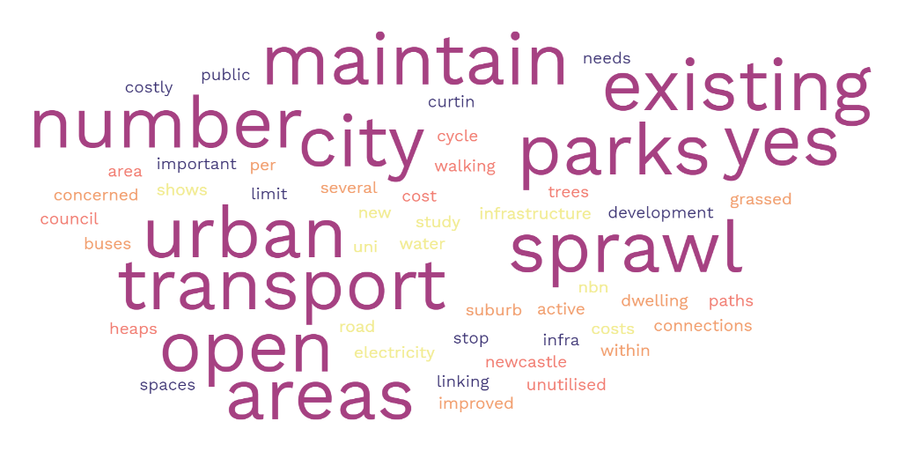
Figure 2: Word cloud of feedback in agreement with the four SIS priorities
Seven respondents extended their support with a comment praising the priorities. Although agreeing with the priorities, one respondent noted that many of the parks and open spaces in Newcastle are underutilised and suggested that additional cycle and walking paths in these areas may increase visitation to these places and spaces.
Table 1: Selection of verbatim comments that agree with the four priorities of the SIS
Agreement with the four priorities of the Social Infrastructure Strategy – Verbatim comments
"The priorities are sound.
"Seems pretty fair"
"great"
"There are several parks and open grassed within the Newcastle area that are unutilised. Must cost council heaps to maintain. More trees and cycle/walking paths through these rarely used areas could work"

However, two respondents who disagreed with the priorities, commented on the need for better transport and connectivity. One respondent suggested that CN should focus on the utilisation and maintenance of existing parks, infrastructure, and facilities.
Table 3: Selection of verbatim comments that disagree with the four priorities
Disagreement with the four priorities of the Social Infrastructure Strategy – Verbatim comments
"I am concerned with the improved transport connections"
"We are not a global organisation we are a community, with real people that pay for these infrastructures via our taxpayer money, mow the grass, open the toilets and maintain the existing roads and surrounding access areas to already existing parks, playgrounds & beaches.

    - Areas that are liked
14 of the 22 submissions discussed what they liked about the SIS.
Priorities, drivers of change and action plan
Seven of the 22 submissions made comments of support for aspects of the strategy. Three respondents commented that they are supportive of Priority 2: Quality and adaptive places to play and stay. Three respondents suggested they are supportive of Priority 1: Equitable distribution for growth and resilience, in particular increasing utilisation, and quality of existing infrastructure (one respondent), and equitable access to transport and facilities for employment and leisure (one respondent). Two respondents also made note of the drivers and actions to achieve the priorities, including the inclusion of benchmarks (one respondent) and alignment with social justice principles (one respondent).
"I liked the drivers of change. Good to see mention of blue green grid and potential benchmarks"
"I like the focus on equity of opportunity and experience and co-location of services. I also like the focus on collaboration"
"It is clearly underpinned by the principles of social justice and well aligned with the delivery of the four priorities guiding the strategy"
Figure 3: Selection of verbatim comments that are supportive of the priorities, drivers of change and action plan included in the draft Strategy

Social infrastructure to support families, children, and young people
Of the 14 submissions that discussed what they liked about the SIS, four submissions made a comment of support for the strategy's focus on social infrastructure to support families, children, and young people. Two respondents suggested that parks and green spaces are important for this cohort. One respondent noted that affordability of facilities is also a priority for this group.
"Opportunities for children and young people
Affordable options for all"
"That there is a plan that includes focus on youth"
"More parks with equipment for kids update"
"The parks are looking great around Newcastle and exciting for future. Especially love the older parks which work with established trees and gardens for my family and guests from out of town to enjoy"

Figure 4: Selection of verbatim comments that are supportive of the focus on social infrastructure to support families, children, and young people

Health and wellbeing
Three of the submissions made comments of support for the focus on social infrastructure to improving health, wellbeing, and connection to other community members and services.
"SI as referenced in the draft strategy provides existing and new communities with anchor points they can connect with and start to build connection with people and place, a sense of belonging and access to social support services"
"Really good to see importance of our public spaces for mental wellbeing!"
Figure 5: Selection of verbatim comments that are supportive of the focus on health and wellbeing in the Strategy

    - Areas that could be improved
All 22 respondents discussed what could be improved or aspects that may be missing in the Strategy.
Utilisation / upgrade / management of existing public places and spaces
Nine of the 22 responses mentioned that the utilisation, upgrade, management (and subsequent maintenance) of existing public places and spaces in Newcastle should be a priority in the Strategy. Four respondents specified facilities and features that could be included in an upgrade, including timers for lights, Wi-Fi connectivity, signage and art and amenities. One respondent also suggested ongoing research and monitoring be conducted to gauge how and when facilities are used.

Table 4: A selection of verbatim comments on areas that could be improved related to the theme utilisation, upgrade and management of existing places and spaces
Areas that could be improved – Existing public places and spaces – Verbatim comments
"Install wi-fi in all community centres and halls. Where suitable install audio systems and ceiling projectors in community centres and halls"
"We have great parks, but they need to be maintained"
"Update facilities in buildings"
"Thank you for investing in Number one cricket ground, however it is not enough to attract big league teams. We need to get funding from state and federal money to improve the dressing rooms, a media box and some grandstands"
"Monitoring of how spaces are used is important. Do we know how many families use city playgrounds, what equipment is preferred by kids, and how people get there (Walk, tram, ferry, car etc)"
"I would like to see the inland pools more prominently acknowledge in the strategy and that there are specific actions to provide for the modernisation and long-term future of all the swimming pools (not just the ocean baths)"
"Haven’t addressed existing areas. Why high growth areas? Why not ALL areas equitably planned for!!!!"

Partnership and funding
Eight of the 22 responses focused on the need for partnership and funding from state and federal governments, as well as community groups, local businesses and industry partners. One respondent suggested that CN should advocate for social infrastructure be considered in the roll out of state and federal government funded social planning projects. Another respondent suggested that CN should partner with big companies in the area to fund projects in the social infrastructure space.
However, one respondent expressed concern that 'big businesses' may monopolise management of public spaces and suggested more support for local businesses is needed. Additionally, another respondent expressed disappointment in current CN processes to support engagement with local sporting clubs/groups and the 'partnership for goals' objective.
Table 5: A selection of verbatim comments on areas that could be improved related to the theme partnership and funding of social infrastructure
Areas that could be improved – Partnership and funding – Verbatim comments
"Increase provision and access to 'social infrastructure' through advocating State and Federal Government funding bodies to mandate in contractual agreements with community service providers that they have a physical presence on the ground (e.g., outreach through community centres) in the localities they have been funded to the service)"
"Funding & Delivery: Council could work harder to forge beneficial partnerships with big companies operating across our region (YanCoal, Glencore, PWCS and others). Apply pressure for them to spend some of their extraordinary profits on long-term infrastructure in the region they are taking from"
"All for adding things to see and do within Newcastle CBD. Cottage industries would be great. Surely, they could be squeezed in somewhere"
"'Partnership for the Goals' In my experience every suggestion to Council that could create partnerships and positivity is rejected. Basic things for sporting clubs - like invoices that are easy to navigate and transparent"
"I am concerned that "big business" can manipulate the management of public spaces. SUPERCARS make demands, require secret agreements, and bring their own cavalcade of merchants - when local businesses are crying out for support"

Connectivity and transport
Seven of the 22 responses noted that greater detail was needed on plans for connectivity and public transport to support social infrastructure, including upgrading footpaths, reliability and frequency of buses, trains and trams, affordability of parking, and proximity to other shops and outlets. One respondent also commented on the need to evaluate and monitor the use of current connecting public transport and walkways.

Table 6: A selection of verbatim comments on areas that could be improved related to the theme connectivity and transport
Areas that could be improved – Connectivity and transport – Verbatim comments
"Buses / active transport (improves body and mind health) work better in well planned higher density cities (with enough green spaces intermixed)"
"Please spend money on improved transport connections on existing infrastructure. The state of local roads is horrific and getting worse with every major downpour. The idea of extending the tram lines is a joke in my opinion and only caters to some of the Novocastrian population"
"Safety getting to and from parks. For example, some parks are dangerous to cross the roads to get there or have very narrow paths with no safety fence very to 60km roads"
"Would like to see it linked more specifically to public transport which is such an issue in Newcastle with major locations such as John Hunter being so poorly serviced by public transport for example"
"Which bike tracks are the most popular? Do people like shared paths and is there respect for other users?"

Other areas
Other suggested improvements included an emphasis on clarifying CN roles, responsibilities and remit (five respondents), community engagement and supporting communications (three respondents), accessibility and affordability (three respondents), alignment with existing policies and strategies (three respondents), equal distribution (three respondents), and climate and sustainability (two respondents).
Table 7: selection of verbatim comments on other areas that could be improved
Areas that could be improved – Other – Verbatim comments
"Explore and implement joint and shared-use opportunities with councils where there is a mutual benefit for the school and community. However, this is subject to timing, funding and a Memorandum of Understanding developed between the parties"
"There is an identifiable gap and that is a long overdue review of the Social Impact Assessment Policy 1999. Recommendation – a review of the SIA fits under Priority 4 Objective 4.1"
"Focus on the “equity” in equitable distribution"
"Could also touch a bit more on the 'blue' - importance of water in our city and major challenges of floods/storms etc"
"Community engagement & communications. There were only 213 community survey participants to understand social infrastructure needs"

4.2 Feedback from workshops
Over the public exhibition period, the CP&D team attended over 15 workshops, including lunch and learn events, advisory committee meetings, informal events with key stakeholder and community groups to discuss the draft SIS and gather feedback. The conversations and feedback were documented across nine of the fifteen sessions. The remaining six sessions were information sessions, so no formal feedback was recorded. Workshops included:
- Guraki Advisory Committee Meeting, Awabakal Local Aboriginal Land Council (26 September 2022),
- 42nd Hamilton South Hall celebration, Hamilton South (28 September 2022),
- Newcastle Youth Council presentation, CN City Library (5 October 2022),
- Drop-in sessions at Hope Street, Baptist Care (12 October, 13 October, and 19 October 2022),
- Diverse Genders and Sexuality Community session, Lambton Park Hotel (17 October 2022),
- Hunter Ageing Alliance Morning Tea & Learn, CN Digital Library (20 October 2022),
- Community Sector Afternoon Tea, CN Lord Mayors Reception Room (26 October 2022),
- Community & Culture Advisory Committee Meeting, City Hall (31 October 2022),
- Making Change in Our Suburbs Meeting, Shortland Public School (9 November 2022),
- Community Disability Alliance Hunter (CDAH) Morning Team & Learn, CDAH Office (15 November 2022)
- Making Changing in Our Suburbs Youth Project, Wallsend Library (16 November 2022)
- Humanitarian Settlement Program Newcastle meeting, Hamilton (16 November 2022)
- Access & Inclusion Advisory Committee Meeting, CN Digital Library (17 November 2022)
- Diverse Genders and Sexuality Representatives meeting, The Edwards (18 November 2022)
- Wallsend Active Hub Open Day (20 November 2022)
- Soul Café meeting, Soul Café Homeless Support Services (22 November 2022)
- Disability & Employment Video launch, CN Digital Library (25 November 2022)
- Liveable Cities Advisory Committee Meeting, CN Lord Mayors Reception Room (29 November 2022)
Deidentified copies of the workshop notes and feedback can be viewed in Appendices 4.

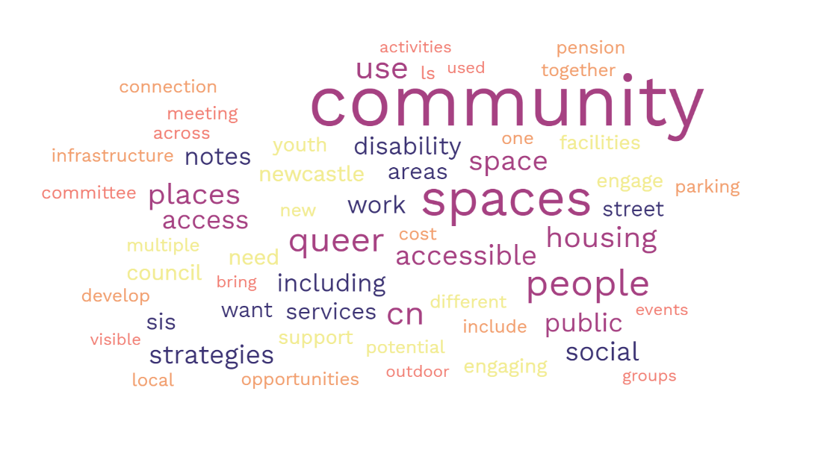
Figure 6: Word cloud of feedback from workshops across the public exhibition period

    - Key themes
Across the feedback that emerged from the workshops, four key themes were identified.
Public spaces and places – Multiuse, utilisation and intergenerational
During the workshops, participants discussed the importance of the strategy supporting social infrastructure and public facilities that are multiuse, better utilised and intergenerational. More specifically, participants called for the Strategy/CN to raise better awareness of the availability and benefit of existing CN public spaces, and to work with community members and organisations to accommodate a variety of activities and events.

Table 8: A selection of verbatim workshop notes on the theme Spaces and places – multiuse, utilisation and intergenerational
Spaces and places – Multiuse, utilisation and intergenerational – Verbatim workshop notes
Seek for greater awareness raising of availability, benefit, and existence of CN's public spaces and places, currently not very visible nor now they can be used by different groups or for different events/activities
Suggest moving away from single use to multi-uses-intergenerational spaces/places. People want multiple activities to participate in/use, their whole family/friends can enjoy in one space such as the new pilot Darby Street Shared spaces street, which has music, eating, seating, drinking, colour dots for kids to play amongst, people watching, shopping
Want a space/place that can for instance have walking dog, basketball net, toilet, birthday parties, afternoon tea gathering spot, all-abilities use, street parties, cultural celebrations, youth socialising, etc. With some parts indoors, opened to outdoors, and outdoors parts connected/visible/linked to other uses.

Public spaces and places – inclusive, accessible and affordable
Public spaces and places that are inclusive, accessible and affordable, including to a variety of groups such as Diverse Genders and Sexuality, Aboriginal and Torres Strait Islander community members, Culturally and Linguistically Diverse peoples, young people, low income households, families, people living with disability, and elderly/ageing was a theme that emerged from the discussions with community members and stakeholders. Additionally, participants discussed that accessible transportation and connectivity would be key to ensure all community members are able to utilise public spaces, places and facilities.

Participants suggested that inclusive social infrastructure would support a variety of events to accommodate for the needs of different groups, such as quiet spaces and alcohol-free night life for Diverse Genders and Sexuality community members. It was also noted that there was support for an increase in social infrastructure in the Western areas of Newcastle.

Table 9: A selection of verbatim workshop notes on the theme Spaces and places – inclusive, accessible, and affordable
Spaces and places – inclusive, accessible and affordable – Verbatim workshop notes
Consider multi-intergenerational for parents/carers, grand/children, youth, elderly, all-abilities LGBTIQ-welcome, etc, where we all can spend a couple of hours and all using the space at various times in various ways.
Engaging spaces are those that are airy light filled; have several differing lounging type areas throughout; offers 'connection to others' opportunities such as a café, all-access community garden, communal tables
Queer community / underrepresented groups don't feel safe coming into CN spaces
Need free WIFI Poles and accessible parking areas.
Renew assets to make more accessible
Parking costs and fines means cannot afford to visit community spaces and places. Consider how to address this for vulnerable cohorts so can access public facilities and services.
Affordability of public spaces/places – idea – If you have a health care card, you are able to pay a reduced cost to access pool, museum exhibition etc as currently too expensive for me and my family.
Demand for different types of facilities including bars that are safe spaces for people to have a drink, but also to chill out. Gateway Bar (previous Gay Bar), ACON next door. No spaces for introverts, mostly extroverts. Look at how to facilitate this. Near queer spaces that are quieter. Queer Spaces are mostly parties, bars how to be more inclusive.

Local government roles, responsibilities, remit, and advocacy
During the sessions with stakeholders and community members, attendees discussed the roles and remit of CN and staff in managing, resourcing and advocating for public spaces and spaces. In particular, participants discussed 'spheres of influence' regarding social infrastructure and which levels of government have responsibility of supporting housing and services. Additionally, stakeholders queried whether CN had remit to provide support via offering complimentary office spaces for community groups and not for profit community service organisations. Participants also suggested CN advocate for other funding/payment approaches, where the community and organisations work together to change goods or something else rather than money.

Table 10: A selection of verbatim workshop notes on the theme Local government roles, responsibilities, remit and advocacy
Local government – Verbatim workshop notes
Be clear in the LS and SIS strategies "Who do the problems belong to?" Spheres of Influence. E.g. for housing and housing wrap around supports, what is councils role, influence etc.
Council could/should develop resources to help businesses be more accessible. Is there an action for this.
Is there scope for CN to provide these sort of office spaces for not-for-profit orgs. Potential for a community services hub.
Consider alternate affordability, funding approaches, for both community to pay entry/hire as well as CN to build/construct new facilities, such as: Local Exchange Trading System (LETS); Let the community work together to exchange goods or services for something else, rather than money.

Community and stakeholder engagement and collaboration
Across the workshops the importance of ongoing community and stakeholder engagement and collaboration to deliver the strategy's' goals and objectives was reiterated. Some suggestions included regular feedback sessions, resource development, and inclusive/accessible engagement approaches.
Table 11: A selection of verbatim workshop notes on the theme Community and stakeholder engagement and collaboration
Community and stakeholder engagement and collaboration– Verbatim workshop notes
Could we have 6 monthly/12 monthly feedback mechanisms on both strategies.
Business involvement. Staged resources for businesses and employers. How to make public spaces more accessible. This is more challenging for small employers and businesses.
Comments on the positive community engagement during public exhibition, particularly going to where community are such as at the Hope St community centre in Wallsend – engaging with people who may not usually be involved in strategic planning.
People who aren't rate payers, can they engage with CN and these strategies. There are many people who are renters and those in social housing. Rates notices is usually the way people engage with CN. It may be more useful to employ a digital campaign to engage.

Final take outs
Overall, the community was very supportive of the draft SIS. Items supported in the draft SIS included:
- The priorities, drivers of change and action plan,
- Social infrastructure to support families, children and young people,
- Health and wellbeing.

Items suggested for refinement in the draft SIS included:
- Greater utilisation, upgrade and management of existing places and spaces,
- More partnership and funding pursued,
- Between and to social infrastructure, improved connectivity and public/active transport,
- Other suggestions included accessibility and (un)affordability of CN social infrastructure, equitable distribution of SI across whole of city, CN community engagement and supporting communications, and climate adaptation/sustainability.

Recommended amendments to draft Strategy based on key themes from public exhibition

Submission Theme | Section / Priority of draft SIS comment relates to  Priorities are:  - Equitable SI distribution  - Quality and adaptive SI  - Community inclusion  - Gov, partnerships & adv | Suggested approach  Note: Supported or not supported in this context relates purely to the inclusion of the comment within the draft SIS and not the merit of the comment in an overall context
Climate adaption considerations – upgraded/new social infrastructure (SI) | Quality and adaptive places and spaces | This suggestion is covered in Action 2.3.3  Principally addressed in other CN strategies and policies eg Newcastle Climate Action Plan, draft Environment Strategy
Connections between SI – public / active transport, blue/green connections, footpaths | Equitable distribution for growth and resilience | This suggestion is covered in Objective 1.3  Principally addressed in other CN strategies and policies eg transport, urban planning
Add more references about need for universal access (disability) of SI | Quality and adaptive places and spaces | Change supported in part. Content already includes value and need for accessibility to SI. Amended content so clearer when referencing disability access.  This suggestion is covered in Action 2.1.3
Enhance existing SI – mow grass, connecting footpaths, car parking, kitchens, wi-fi, multiple uses, etc | Quality and adaptive places and spaces | This suggestion is covered in the suite of actions in Objectives 2.1 and 2.2, and Action 1.1.1
Enhance existing SI to be "welcoming spaces" for all – youth, First Nations, Queer coded, girls, disability (practical needs), intergenerational | Community capacity building and inclusion | This suggestion is covered in Objective 3.2  Welcoming and safe spaces principally addressed in other CN strategies and policies eg Newcastle Local Social Strategy
Add references about leasing and facility management of City of Newcastle (CN) owned community centres and halls | Governance, partnerships, and advocacy | Change supported in part. This suggestion is covered in Actions 4.1.4 and 4.3.1. Amended Priority 4 content to include reference.
Increase programming offered at CN-owned community centres and halls | Community capacity building and inclusion | This suggestion is covered in Actions 1.1.1, 3.2.2 and 4.1.4  Principally addressed in other CN strategies and policies eg Newcastle Local Social Strategy
New/added back in actions in response to exhibition feedback |  | 4.1.1. Establish an internal forward planning governance group to coordinate decision making relating to social infrastructure planning and investment  4.1.6 Establish long-term strategic relationships with NSW Government land organisations to support SI investment alignment with evidence-based needs and prioritisation

Additional amendments to SIS:
- Change all timeframe references of 2021-2025 to 2023-2026
- Acknowledgement of Country update
- Demographic and organisational structure updates (sections: Our Newcastle and Action Plans)
- New content added (section: Our policy drivers)
Added content relating to the recently released NSW Hunter Regional Plan 2041, Department of Planning and Environment 2022
- New content added (section: Innovation and best practice trends)
Added further clarification distinction between ‘community hubs’ that are one-stop-shop type buildings or spaces such as CN's Digital library, customer service centre, council chambers and above, council administration centre and DPE defined ‘neighbourhood hubs’ that cover several streets/blocks to whole local centres and its supporting transport, commercial areas, schools etc.
Also, combined into one para under heading Multipurpose, shared and flexible design, the three previously separate para's Multipurpose, shared and flexible design; Shared use of social infrastructure; and Going up: stacked and rooftop social infrastructure
Based on exhibition feedback, added reference to community centre and hall facility management agreements to para 'Partnership and collaboration funding and management models'.
- New content added (section: source references)
Added reference list at end of document.

- Minor general spelling and editing changes.

Appendix 1 – Promotional materials
Have your say webpage

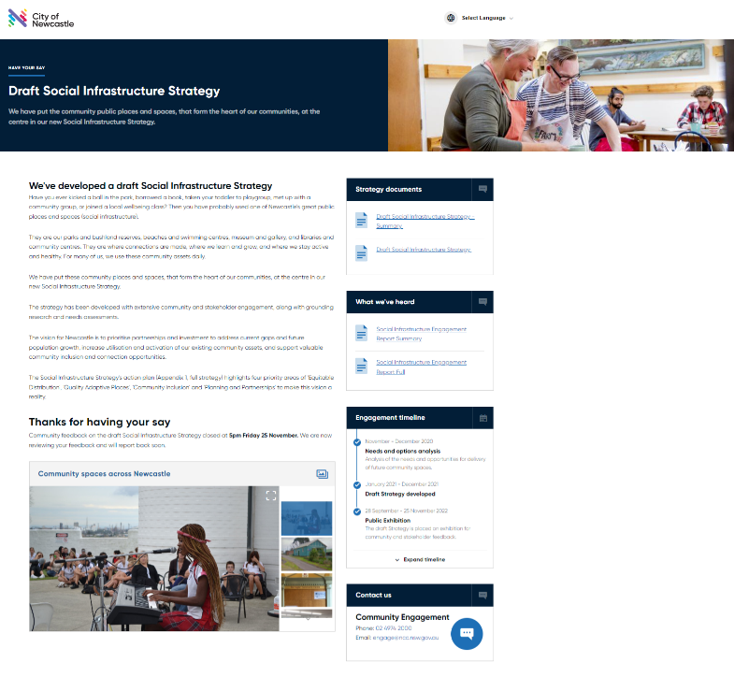

Postcard

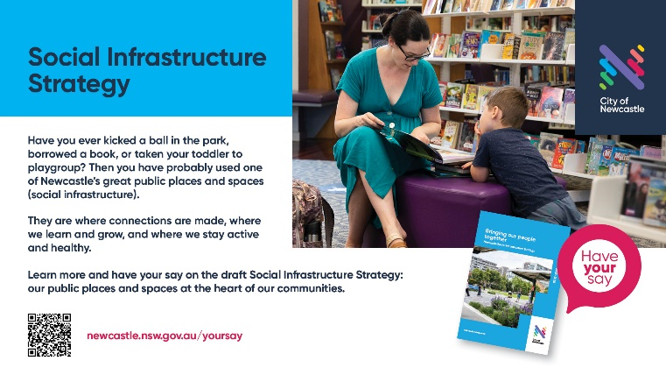

Social media
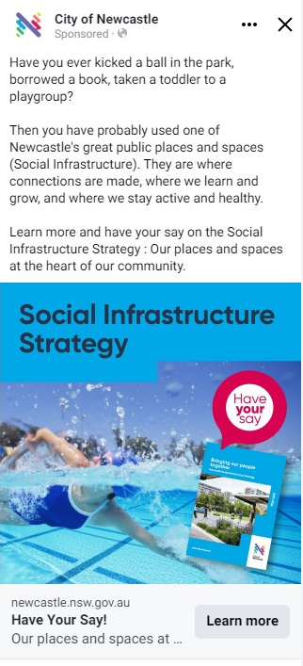

Media release
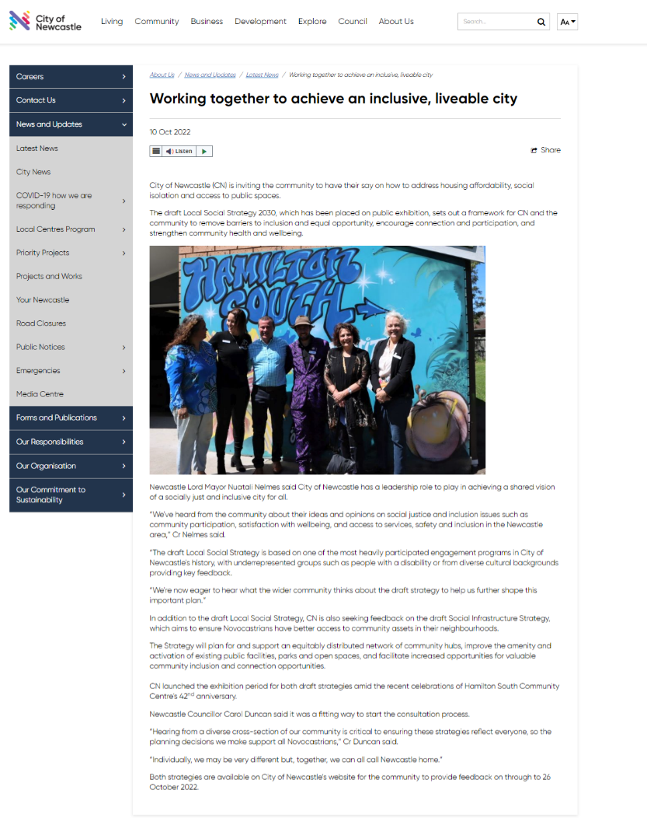

Appendix 2 – Online feedback form
[Page 1]
The Social Infrastructure Strategy (the city's public places and spaces)
Have you ever taken your toddler to playgroup, met with a community group, joined a local yoga class, kicked a ball with your friends in the park, or borrowed a book? Then you’ve probably used one of the great public places and spaces (social infrastructure) in Newcastle. They are our parks and bushland reserves, beaches and swimming centres, museum and gallery, and libraries and community centres.
In 2021, we heard from people across the city to understand what they value about our city’s public places and spaces now and into the future. These ideas and feedback were used to develop an important framework called the Social Infrastructure Strategy.
This framework is now on public exhibition, and, in the below online form, we would welcome your feedback. If you'd like to submit a written response, please email engage@ncc.nsw.gov.au . Or
[Page 2]
Please review the draft Social Infrastructure Strategy (summary or full version), or below key sections of the Strategy to answer the next questions.
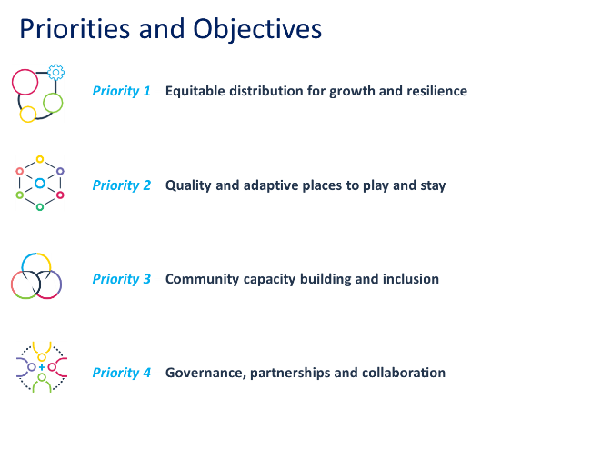
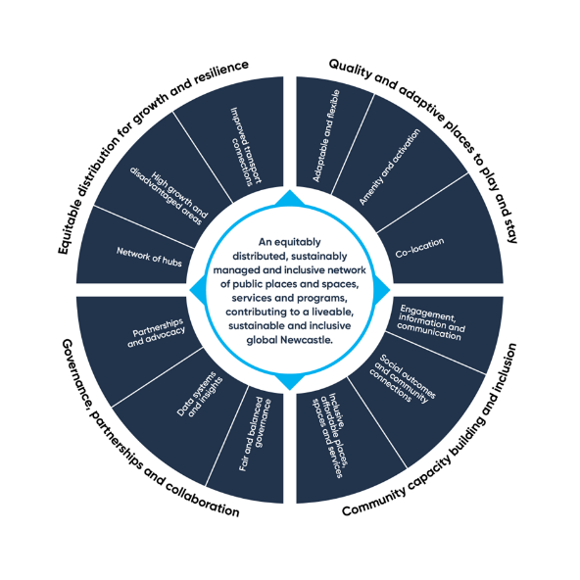

Do you agree with the four priorities of the Social Infrastructure Strategy?
Yes (open response)
No (open response)
Not sure (tell us what's missing) (open response)

What parts of the draft Strategy do you like?
[Open response]

What parts of the draft Strategy could be improved?
[Open response]

Do you have any additional comments about the draft Social Infrastructure Strategy?
[Open response]

[Page 3]
Your details
Name
[Open response]
Suburb
[Open response]
Email
[Open response]
I'd like to receive further information from City of Newcastle related to social infrastructure
Yes (please make sure your email address has been provided above)
No

[Page 4]
Thank you for your feedback.
For more information about the Social Infrastructure Strategy, head to: https://www.newcastle.nsw.gov.au/have-your-say/projects/social-infrastructure-strategy
-End form-
Verbatim responses – online feedback form
What parts of the Strategy do you like? (Open ended)
That there is a plan that includes focus on youth.
overall strategies seem good but there will be too much urban sprawl and too mush wasted money on cars. Need to spend on safe and health
All four.
I liked the drivers of change. Good to see mention of blue green grid and potential benchmarks.
Really good to see importance of our public spaces for mental wellbeing!
I like to focus on equity of opportunity and experience and co-location of services. I also like the focus on collaboration.
Quality and adaptive places to play and stay.
Quality and Adaptive places to play and stay.
None as too vague
Would like to know more information, perceived meaning of your strategies
none
Equitable distribution for growth -
*Improving the quality and amenity of what we have
*Intergenerational spaces
*Adaptive places.
Note. Broadmeadow and Adamstown areas have a huge increase in apartments and residents, who will need well designed multipurpose spaces, inter-generational space/facilities, community and recreation facilities, public places eg libraries
Focusing on liveability and environmental sustainability.
Equitable access to transport, facilities and opportunities for employment and leisure.
Opportunities for children and young people
Affordable options for all
Enliven the city - except nothing as disruptive as Supercars which I loathe
The ideas are good but experience with Newcastle Council shows that they are resistant to change, don't support community groups and volunteers and will never achieve any of their goals.
more parks with equipment for kids update
Quality and adaptive places to play:
The parks are looking great around newcastle and exciting for future. Especially love the older parks which work with established trees and gardens for my family and guests from out of town to enjoy
What parts of the Strategy could be improved?
Make mention of where to location of skatepark at Broadmeadow near PCYC for youth. Near food and drink outlets and train station. Youth activities to occupy them and create spaces for them to be welcomed and they enjoy.
Monitoring of how spaces are used is important. Do we know how many families use city playgrounds, what equipment is preferred by kids, and how people get there (Walk, tram, ferry, car etc)
Who uses the skateparks?
Which bike tracks are the most popular? Do people like shared paths and is there respect for other users?
Is there sufficient parking at southern beaches - and should the LR be continued to Nobbys and the Ocean Baths?
Urban sprawl is too costly: A 2009 Curtin uni study shows infrastructure (road, water, NBN, electricity etc) costs for a new suburb are $684,000 per dwelling (Curtin_Sustainability_Paper_0209). Buses / active transport (improves body and mind health) work better in well planned higher density cities (with enough green spaces intermixed). With the "extra" money the gov could even build more social housing (experts say this is a priority to make housing more affordable). Like climate change, re
As mentioned earlier. Some open grassed areas that are not used enough. It's great to have these open areas, but maybe more could be done with them.
The 'why it matters' pg15. section is okay, but would be very good to see mention of Extreme Heat Events and Urban Heat Island as challenges to our city, and how important our social places are for combatting this (bushland, street trees, parks etc.). CN has urban heat mapping and targets in the Draft Environment Strategy to increase canopy cover across the city.
There is not adequate attention to the role that aquatic facilities and swimming pools can and do provide as both social, cultural, health and wellbeing facilities. I would like to see the inland pools more prominently acknowledge in the strategy and that there are specific actions to provide for the modernisation and long term future of all the swimming pools (not just the ocean baths).
4. Make sure this is across all community, especially all sports.
Look at all areas of public space.
Focus on the “equity” in equitable distribution. Haven’t addressed existing areas. Why high growth areas? Why not ALL areas equitably planned for!!!!
Being detailed in your meaning of what you will do.
scrap your smart cities and fix the existing Infrastructure
Community engagement & communications. There were only 213 community survey participants to understand social infrastructure needs.
See comments below
Funding & Delivery: Council could work harder to forge beneficial partnerships with big companies operating across our region (YanCoal, Glencore, PWCS and others). Apply pressure for them to spend some of their extraordinary profits on long-term infrastructure in the region they are taking from. Make it a mark of social standing to have invested in the long-term future of our city and region, gives them a better image and benefits the city and region that will have to mop up once they are gone.
It’s very general, no specific examples to comment on
Partnership for the Goals' In my experience every suggestion to Council that could create partnerships and positivity is rejected. Basic things for sporting clubs - like invoices that are easy to navigate and transparent. Apparently that's too hard and volunteers have to spend hours trying to understand them. Timers for lights - nope. Too hard, no funding, club has to pay and fill out lots of forms. This whole strategy doesn't match the lived experience of dealing with CoN.
Update facilities in buildings
Safety getting to and from parks. For example some parks are dangerous to cross the roads to get there or have very narrow paths with no safety fence very to 60km roads.
Do you have any additional comments about the Strategy?
I am concerned that "big business" can manipulate the management of public spaces. SUPERCARS make demands, require secret agreements, and bring their own cavalcade of merchants - when local businesses are crying out for support. NRL and professional sport seek control over swathes of public recreations space. Developers, including HUNTER AND CC DEVELOPMENT CORP leave small passive public spaces, but baulk at providing larger areas for more active recreational activities. Cyclists feel ignored, kids want more activities
Please spend money on improved transport connections on existing infrastructure.
The state of local roads is horrific and getting worse with every major downpour.
The idea of extending the tram lines is a joke in my opinion and only caters to some of the Novocastrian population. No one in my family has used the Newcastle tram once not even when it was opened and travel was free. All the tram line has achieved is that I only go to Newcastle CBD when absolutely necessary. Prior to their installation, I would have visited weekly. The concept that people will sell their cars and use public transport and trams is nearsighted and unsustainable without major upgrades to existing services. Trams have been previously used in Newcastle only to be ripped out and replaced. Whereas the use of roads impacts everyone whether they be accessed by public transport, private car or community bus or bicycle.
All for adding things to see and do within Newcastle CBD. Cottage industries would be great. Surely, they could be squeezed in somewhere. I know it's been tried before. Give some enthusiastic young people a chance to get started in their own little business ventures. The CBD is beginning to thrive. If I could afford to, I'd move there right now! The more varied the place is the better.
Could also touch a bit more on the 'blue' - importance of water in our city and major challenges of floods/storms etc... Our public spaces are excellent at capturing and storing flood waters and mitigating impacts on private property.
I do not think that Newcastle should be trying to get a new aquatic centre built at Broadmeadow. I think the effort should be on restoring and managing the current swimming centres. I would like to see an specific action in the strategy to restore and modernise the Lambton Park Memorial Swimming Centre.
Quality should be improved for public space. Cutting grass in parks for people to play should be monitored more. Grass should not be knee height before being cut. We have great parks, but they need to be maintained. And this was happening before the wet weather.
I like how the Council is being involved in growing our cities attractions in sport, car racers, soccer and rugby league. Thank you for investing in Number one cricket ground, however it is not enough to attract big league teams. We need to get funding from state and federal money to improve the dressing rooms, a media box and some grandstands. Newcastle could easily have a WBBL or BBL team of their own. It would create great wealth for Newcastle. With the state election coming up, this is the time to get action for grants.
Strategy not clear or specific. Conveniently vague to ensure already decided plans are enacted. Token consultation process
It should be specific, not generalized and to manipulate
won't make a difference we will own nothing and be happy
Question - Can this be implemented without satisfactory community engagement?
Would like to see it linked more specifically to public transport which is such an issue in Newcastle with major locations such as John Hunter being so poorly serviced by public transport for example.
I would like to see more regarding how Awabakal land will be recognised and the local Aboriginal community be part of core decisions regarding social infrastructure.
Glad to have it, although the timeframe is long before many benefits will be realized. Could re-work to take it on in smaller chunks so that progress is measurable and visible in shorter time spans.
Make this an exciting city for all, attractive for our kids to want to stay in rather than move to other larger cities
Just do the basic things the community expects of you and stop writing Strategies that you are incapable of achieving.
You can't even make a form that accepts an entire email address.
Peace Park Tighes Hill is very beautifully landscaped and could have better and safer access for families to picnic there. The path that is on maitland road is very dangerous as it is too close to the fast traffic and not wide enough. If possible it would be fabulous to widen the bridge over styx creek (throsby creek at islington tighes hill section). It could be widened over the creek more and also guard rail to protect kids/cyclists from falling into fast traffic. Also, the arbours in the park could be painted white and climbing flowers planted around it. I will email engagement team the photos of the dangerous pathway.

Appendix 3 – Other submissions
Submission 1
Has been de-identified
Thank you for the opportunity to comment on the City of Newcastle (CN)’s Draft Social Infrastructure Strategy. I congratulate the organisation on the preparation of the Draft Social Infrastructure Strategy. I support the priorities as identified.
I wish to make the following observations and recommendations
- The action plan is short at only 4 years.
  - Recommendation - The term of the plan needs to be longer with short-, medium- and longer-term actions to ensure that the desired vision can be met.
- There is an identifiable gap and that is a long overdue review of the CN Social Impact Assessment Policy 1999.
  - Recommendation – a review of the SIA fits under Priority 4 Objective 4.1
Newcastle was one of the first Councils in NSW to develop and adopt a Social Impact Assessment Policy as part of the development assessment process. Social issues cover all aspects of human life including how we live, our culture, our community, our health and wellbeing and our aspirations. The terms SIA process, Social Impact Assessment, Community Impact Assessment and Health Impact Assessment are taken to be interchangeable terms and to have a similar intent.
The existing SIA Policy (1999) has not been reviewed and updated since its adoption and implementation. As one of the first SIA policies in NSW, its focus was on development applications. The SIA policy is part of Council's Development Control Plan (section 4.05) under Section 4 Risk Minimisation Provisions.
The purpose of social impact assessment is to provide a professional assessment of the likely social consequences of proposed actions or events, so that serious adverse social outcomes can be avoided. An SIA is both an anticipatory and a precautionary process that refers to the assessment of the social consequences of a proposed decision or action (development proposals, plans, policies, and projects) on affected groups of people and on their way of life, life chances, health, culture and capacity to sustain these.
The underlying principles in the current SIA Policy require review and updating to better align with the international principles for SIA (IAIA, Vanclay, 2003) and good practice approaches as supported by the Planning Institute of Australia (PIA, 2010) to make clearer the basic principles of SIA - intra-generational equity (distributional equity) and the precautionary principle
Current research and the recent lived experience during Covid have highlighted the importance of the built environment for community wellbeing and overall health.
The current SIA policy applies only to development applications. Undertaking an SIA at the DA stage of development is not sufficiently strategic, resulting in an ad hoc approach to impact assessment and mitigation.
Consideration needs to be given to refocusing and broadening the scope of Council's use of SIA similar to eg Liverpool Council SIA Policy 2015 - S5.4 - SIA applies to development, strategic land use planning eg LEP's, masterplans; new projects, policies or plans that may trigger social change; use of social impacts in Council reporting processes, use of an initial assessment form for social impact comments and identification of criteria for acceptable mitigation measures.
Conclusion
A review of the City of Newcastle SIA Policy (1999) would enable and further enhance the capacity of the City to identify and respond to current and emerging social infrastructure issues in more proactive, innovative and appropriate ways

Submission 2
Has been de-identified

- Provides essential social infrastructure for the direct benefit of the local community. Public schools in NSW are required to provide a suite of complementary facilities (such as open space) to service the needs of the student population. Further, these sites are often made available for community when suitable conditions are met.
- Shared Use of Facilities: page 17 of the draft Strategy states the following:
“Work is currently being undertaken to explore shared-use arrangements with schools in Newcastle, and how to increase usage of facilities that are currently underutilised or only available to a single user group” …
- Seeks to explore and implement joint and shared-use opportunities with councils where there is a mutual benefit for the school and community. However, this is subject to timing, funding and a Memorandum of Understanding developed between the parties. ]
As a result of the above, request that the comment above be amended as follows:
“Work is currently being undertaken to explore shared-use arrangements with schools in Newcastle, and how to increase usage of facilities that are currently underutilised”
- Generally supportive of Action item 1.3.1 of the draft Strategy which aims to support enhanced connections to social infrastructure within the LGA.
- Request that transport planning for the LGA be guided by the NSW Governments Movement and Place Framework (MAPF). The MAPF’s core ‘Amenity and Use’ and 'Primary Schools' Built Environment Indicators are of particular importance to, as these encourage urban designers to consider the impact on adjacent places/uses, as well as emphasising movement that supports place.
- The 'Primary Schools' indicator provides two specific metrics to judge the effect of infrastructure on the accessibility of public schools in an area; these being walkability and public transport access. These metrics require designers to assess whether proposed infrastructure facilitates access to primary school facilities (or public transport connections to schools) or whether it exacerbates gaps in the network.

Submission 3
Has been de-identified
Introduction:
I would like to commend the City of Newcastle on the development of the new 'Draft Social Infrastructure Strategy' and for the opportunity to provide comment.
Comments are based on understanding the needs and aspirations of local residents derived through our organisation providing community support services, community development initiatives and our management of the following facilities on behalf of the City of Newcastle:
  - Minmi Pioneers Hall
  - Fletcher Community Centre
  - Maryland Conference Centre
  - Maryland Neighbourhood Centre
  - Wallsend Pioneers Memorial Hall
  - Elermore Vale Community Centre
  - Elermore Vale Community Hall
Assessment of Draft Social Infrastructure Strategy:
It's great to see the primary purpose of providing SI is to benefit 'people'. This is reflected in the recognition of the role 'hard and soft infrastructure' plays in building community connections between people, with places, support services aimed at meeting their needs and aspirations.
The Draft Strategy provides a clear road map to guide the planning, delivery and activation of Council's SI to maximise community benefit now and into the future. It is clearly underpinned by the principles of social justice and well aligned with the delivery of the four priorities guiding the Strategy.
The table on the next page provides comments and recommendations deemed as beneficial to each of the four priorities in the Strategy.
Priority | Comments | Suggested  Recommendations
1. Equitable distribution for growth and resilience | The baseline provision of SI levels to meet the demands of existing and future populations should be determined by several factors besides population size and regional, district and local population catchment areas  The draft strategy makes reference to other  considerations in this regard (eg; remote/rural  localities, vulnerable residents who have  limited means to access SI due to socio-  economic disadvantage factors, physical and  social isolation factors).  Conversely the forecast in increased densification in the Newcastle CBD and around  train stations will require consideration of additional greenspaces / parks and associated SI (e.g., multi-age play/fitness equipment) to offset the reduced residential yard space common to single residential dwellings.  In regards to the new residential development areas in the western growth corridor, the timing of the delivery of SI is critical. Research indicates that providing SI at the earliest stage in new residential developments acts as an early intervention measure.  SI as referenced in the draft strategy provides existing and new communities with anchor  points they can connect with and start to build connection with people and place, a sense of belonging and access to social support services. | 1. Baseline standards guiding the planning, provision and retention of SI include locality based 'social impact assessments'.  2. Consideration of planning mechanisms and Developer incentives to minimise the timing residents in new residential areas have to wait for the provision of SI on the ground.
2. Quality and adaptive places to play and stay | Multipurpose SI enables flexibility  and fosters mixed use, and inter-generational benefits catering for all individuals and communities.  Mixed uses of multipurpose SI provides  synergies and incidental opportunities /  connections for crossover of users between  onsite activities /programs (eg, grandparent  dropping grandchild off at a dancing class at a  community centre discovers a Seniors Group is  on at the same venue which they can join).  The fit out of SI correlates with usability and  subsequent utilisation rates as referenced in  the draft strategy: - New Technologies:  support service delivery, creative industries,  learning and community building (egg wi-fi  accessibility).  This includes provision of seating, shade in  parks and playgrounds etc plus landscaping  (for beautification and natural barriers to contain children to aide with parental/carer supervision).  Caution should be given to not 'over-design' SI  resulting in the exclusion of creative play,  imaginative interaction and use of SI and  surrounds.  Quality of SI correlates with desirability levels for prospective users and utilisation levels. Quality does not necessarily correlate with the age of SI. Research indicates that the overall presentation and maintenance of SI plays a greater role in determining quality.  Co-location of SI based on concepts of hubs services by other services, public transport nodes, retail and medical services is mutually beneficial when there is compatibility and positive social impact assessed benefits. | 3. Reclassify community centres and halls from 'single use' to classification of 'multipurpose'.  4. Install wi-fi in all  community centres and  halls.  5. Where suitable, install  audio systems and  celling projectors in  community centres and  halls.  6. Consideration be given  for inclusion in Council's  Asset Management  Plans for specific SI  which will be targeted for  renovation to rejuvenate  the quality and  desirability for  Quality of SI correlates with desirability levels  community use (e.g.; kitchen renovations in halls).
3. Community capacity building and inclusion | The provision of SI without a planned strategy to activate is a key cause of SI having nominal community benefit (white elephant theory).  The draft strategy recognises the importance of  this stating:  Activation of facilities: making our assets work harder, taking what we already have and making it work better for our community'  Public places and spaces provide community focal points that can anchor people together, including in times of crisis (eg COVID-19 pandemic, floods). The services, programs and activities housed within these public places and spaces connect people and strengthen community resilience.  To ensure people 'will come' 'if you build it'  requires the employment of community  development, cultural development practices  and marketing strategies. This requires the  'multi-agency response' stated in the draft.  In our experience staffing of community  facilities (le; paid staff and/or volunteers) to  enable Centres to remain open on weekdays is  a key contributor to people visiting the Centres  for help, assistance or inquisitive enquiry. This helps foster connection with place, people and available 'soft infrastructure'.  SI belongs to the community and is provided  for the enjoyment and benefit of all individuals  and communities. It is imperative that residents experience of accessing Si is  welcoming, respectful, and culturally safe. This  is supported by the draft strategy:  Inclusive and welcoming social infrastructure designed, managed and programmed for all in our diverse community to enjoy | 7. Increase provision and  access to social  infrastructure through  advocating State and  Federal Government  funding bodies to  mandate in contractual  agreements with  community service  providers that they have  a physical presence on  the ground (eg; outreach  through community  centres) in the localities  they have been funded  to service. This is in lieu  of the traditional service  delivery centralisation  model from a sole  location (eg; Newcastle  CBD).  8.  Incorporate public art in  planning and provision  Si (eg; public parks,  community facilities).  Incorporate cultural  development practices  to give people  connection, ownership  and acceptance of SI.  9. Provide signage on all  helps foster connection with place, people and  SI (eg; community facilities) including:  Signage on front of buildings  Kerbside signage outside each community facility which is welcoming and promotes the facility to people  Signage listing the availability and 'what's on'  Interpretive plaques;  Cultural recognition  10. Allocate funding Tor  'activating' (and staged  ongoing re-activation) of  existing and new SI for  example:  Community events in parks and community facilities  Seeding grants and/or initial waiving of hire fees to support expansion and/or re-location of community support services to occupy outreach to other locations /remote areas.  11. Identity, maximise and support opportunities  which enable community  facilities to be staffed  throughout the week to  maximise community  access (le; virtual  neighbourhood centre  function -  info/advice/referral).
4. Governance, partnerships and collaboration | In our experience the decentralised localised management of community facilities provides a range of community benefits including:  Utilisation of available staffing and volunteer resources to staff venues;  Targeted strategic activation of community facilities through community development practices, established networks, partnerships and knowledge of residents needs and aspirations;  Currency of reputational credibility and goodwill nurtured over time with residents and partners (buy in).  Property management advantages including rapid response (due to physical onsite presence) to maintaining facility presentation (eg; cleaning, waste management, building security response, minor repairs, escalation to Council of other matters, person centre customer service with assistance with public enquiries and hiring etc).  However the sustainable management of SI is imperative as referenced in the draft Strategy:  "ensure equitable and transparent fees alongside sustainable revenue systems"  "… the management of assets such as community facilities relies on revenue methods that generate reliable and increase sources of income to improve financial viability and sustainability"  "…..there are additional, often significant costs associated with the management of community facilities and assets (such as general upkeep, maintenance and repairs), as well as recurring operational costs relating to resourcing, staffing and service delivery." | 12. Sustainable asset  management model/s  aim to achieve as a  baseline 'full cost  recovery' for bodies /  community  organisations delegated  with management  responsibility for  community facilities;  13. Council to introduce additional 'hirer classifications' within it's annual feed and charges (with reference to 'capacity to pay') in lieu of existing two tier classification of:  i. Not for profit / charity  ii. Commercial / private  14. Permit bodies / community organisations delegated with management responsibility of Council's community facilities to assume full responsibility for managing and maximising community benefit and utilisation of facilities (independent from Council) whilst maintaining adherence to Council policies, procedures and objectives relating to Council provision of SI.  15. Specify social outcomes in management agreements in line with Council's 'Draft Local Social Strategy'.

Appendix 4 – Workshops and events notes / feedback

Hunter Ageing Alliance – Morning tea & learn workshop
Notes
Seek for greater awareness raising of availability, benefit, and existence of CN's public spaces and places, currently not very visible nor now they can be used by different groups or for different events/activities. CN could advertise 'eccentric' ideas for how spaces/places can potential be used to spark interest, novelty factor to entice utilisation and bring in new users, e.g. "Did you know in this space you can run an outdoor evening photo slide show, community-cooperative equipment repair sessions, etc". Also, routinely promote via broad range of channels awareness of how to book spaces/places.

Would like more to do at/in each space/place, for instance exercise equipment on its own is exposed, single use, not great for enticing multiple different ways to use or multiple hours of use in one sitting. Suggest moving away from single use to multi-uses-intergenerational spaces/places. People want multiple activities to participate in/use, their whole family/friends can enjoy in one space such as the new pilot Darby Street Shared spaces street, which has music, eating, seating, drinking, colour dots for kids to play amongst, people watching, shopping.

Would like a more multi-destination model rather than single use. Want a space/place that can for instance have walking dog, basketball net, toilet, birthday parties, afternoon tea gathering spot, all-abilities use, street parties, cultural celebrations, youth socialising, etc. With some parts indoors, opened to outdoors, and outdoors parts connected/visible/linked to other uses.

Along with considering spaces for young children (playgrounds, etc), add to this, engaging public spaces/places for youth and the elderly as there is not a lot for these groups. Consider multi-intergenerational for parents/carers, grand/children, youth, elderly, all-abilities LGBTIQ-welcome, etc, where we all can spend a couple of hours and all using the space at various times in various ways.

Want engaging 'lounge room' type public spaces/places, e,g, like some UK libraries and pubs, where you feel relaxed to stay for hours at no-low cost, welcoming to all in the community, with both indoor and outdoor space to access.

Engaging spaces are those that are airy light filled; have several differing lounging type areas throughout; offers 'connection to others' opportunities such as a café, all-access community garden, communal tables, etc; visible to those passing by (glass windows, opens up to outside areas); very affordable; anchored with a key node such as school, retail shopping, public transport; has intergenerational equipment/activities; outdoor areas included.

Spaces that are not engaging are those with sad garden areas where it's just grass, or unkept, limited greenery, limited small kitchen facilities, not facilitating connection opportunities to others using the space or walking by, closed off from outside street movement/surrounded by four walls.

Community Sector – Afternoon Tea & Learn Workshop
Notes
How do we classify Newcastle, either as metro or regional. CN sees itself as Metro. Can this be articulated/reflected in the SIS.

People who aren't rate payers, can they engage with CN and these strategies. There are many people who are renters and those in social housing. Rates notices is usually the way people engage with CN. It may be more useful to employ a digital campaign to engage.

There are no Queer spaces/infrastructure

Inequity is not just geographic, beyond that for queer communities.
Good that the data included in the SIS backs up understanding of lack of social infrastructure in western areas of Newcastle.

Queer community / underrepresented groups don't feel safe coming into CN spaces.

Disability community has practical needs

Overall, very impressed, but there was a lot of content, and it was a bit difficult to summarise [my] thoughts on its entirety, but the below are things that resonated strongly with participant. The main themes from discussion were desire for more authenticity and genuine approaches to community development and social infrastructure.

CN has done well in reinventing the use of their libraries. Doing really amazing work in non-traditional activation (night-time, exhibitions, workshops, outreach).

Need to keep taking a genuine and authentic approach to addressing these to make sure that 'all' locations are treated equally.

Need free WIFI Poles and accessible parking areas.

Locations of Housing Developments are isolated. Building in outlying suburbs is great in many senses but what about accessibility in terms of transport for people who do not have a car – being able to get to distances and multiple locations is a huge issue for people who are vulnerable and trying to make a go of things (get to school, work, support services).

Participant works with people who are in crisis accommodation in Wallsend and need to get to CBD for school, appointments, and work, and this typically takes a whole day due to unreliable, unlinked public transport services.

Community Development Alliance Hunter
Notes
Housing disability making housing more accessible for people with disability (PWD).
Independent Living Option National Construction Code, including Liveable Housing Code, Accessibility (Commonwealth. Accessible Living Guide) (NSW hasn't adopted this).

Consider alternate affordability, funding approaches, for both community to pay entry/hire as well as CN to build/construct new facilities, such as: Local Exchange Trading System (LETS); Let the community work together to exchange goods or services for something else, rather than money. HunterLETS (www.communityexchange.net.au); TimeBanking - Established by NSW Government, but recently being taken down due to lack of use. Negative Interest Money - can be issued by community. Not restricted, but enhanced, by Government participation. Moves around economy eight times faster than normal money “Hot Potato;" Barter - BarterCard and BBX, business to business; National dollars - Conventional; usually used in monoculture.

Advocate for pensions/disability, particularly couples who get less than two singles. Those with disability pension also impacted – including choices about working. In some situations, 75% of pension taken for living arrangement. Only people over 67 years can access higher threshold for pension. Need for advocacy for people on disability pension.

Council could/should develop resources to help businesses be more accessible. Is there an action for this. Potentially better suited to the Disability Inclusion Action Plan.

How to continue the community feedback loops? How to increase citizenship engagement for these strategies and access to Council. Include a list of accessible venues across the city. Potential for Sparrow to do this. SIS will include this for the CN venues and sites. Central Coast Council did this work through an App. Potential to develop a website to identify accessible venues – needs to be led by people w, disability

Renew assets to make more accessible

Community centres seem to be disappearing.

Housing – gentrification of Newcastle

CDAH couldn't find an office space for first 18 months. Is there scope for CN to provide these sort of office spaces for not-for-profit orgs. Potential for a community services hub. Leverage Developers 7.11 contributions

Could develop a set of Resources for diverse community that focus on how to engage with Council, how to use the tools, and how to stay updated on progress regarding strategies. What are the mechanisms to engage with communities regarding customer service (i.e., official request can just be a phone call, email, form).

Could we have 6 monthly/12 monthly feedback mechanisms on both strategies.

Business involvement. Staged resources for businesses and employers. How to make spaces more accessible. This is more challenging for small employers and businesses.

Related courses at Newcastle University. Innovation and Entrepreneur / Creative Industries Course that looks at hypothetical problems. Design focus on Social Innovation. Use practical CN examples in courses. Explore internships and placement opportunities for young people.

LGBTQIA+ Representatives meeting
Notes
Accessibility and inclusive places and spaces

Queer coded spaces, including rainbow / pride flags (clearly queer friendly). Make sure the LS / SIS / all of CN are aggressively welcoming for queers. Make this obvious.

Gender neutral bathrooms, including sanitary bins in Men's bathrooms. Accessible cubicles.

Queer friendly / alcohol free events, especially for underage 18 years

Capacity building events. The queer community not socially adept at some key skills ie. job interview skills. Queer identified facilitators are very important, including those who are openly Queer identifying.

Youth need info on healthy relationships, consent, sex education. Include examples of queer couples. A series of workshops called "It gets better" that could link this with healthy relationships, opportunities for work, social networking.

Demand for different types of facilities including bars that are safe spaces for people to have a drink, but also to chill out. Gateway Bar (previous Gay Bar), ACON next door. No spaces for introverts, mostly extroverts. Look at how to facilitate this. Near queer spaces that are quieter. Queer Spaces are mostly parties, bars how to be more inclusive. Alcohol and drug culture is strong in Queer community, want to provide other options for community. ACON office in Sydney is big and has a community hang out space. Want a multi-purpose, diverse community facility could we do this in Broadmeadow. Collaborate with urban planners.

TOILETS continue to be a big issue for queer community.

Infrastructure. Having a space would be big deal. Including access to printers, computers, community services.

Community & Culture Advisory Committee Meeting
Notes
No questions were asked about the strategy, but committee members were very positive about both and commended the extensive community engagement, evidence-based approach and stressed the importance of this work for the City.

Comments on the positive community engagement during public exhibition, particularly going to where community are such as at the Hope St community centre in Wallsend – engaging with people who may not usually be involved in strategic planning.

Discussed Inner West Council as an example of how to better use council facilities, including opening up their town halls for access to artists/creatives etc

Newcastle Pride – get involved in the Youth Formal they held this year for the first time. Can Local Social support this further?

Include Newcastle PRIDE and ACON Hunter emailing lists

Liveable Cities Advisory Committee meeting
Notes
Members showed support for both the LS and SIS – agreeing with the four strategic priorities presented in both strategies. They commended both strategies on their evidence base, community informed approach and agreed that there was a need for both strategies in the Local Government Area.

Clarify linkage between the LS and SIS and how to differentiate the two documents i.e., is there a doubling up of work in both?

Clarify costs of resourcing the strategies.

Access & Inclusion Advisory Committee meeting
Notes
Inequalities across the LGA to be addressed, particularly across Ward 4. Request for at least one district level facility be included across each district to ensure equitable distribution.

Soul Café
Notes
Be clear in the LS and SIS strategies "Who do the problems belong to? Spheres of Influence. E.g. for housing and housing wrap around supports, what is councils role, influence etc.

One-stop-shop/hubs needed, e.g more Wallsend Hope Street's, Soul Cafes. For example, NSW Department of Community and Justice (DCJ) Social Housing staff with GP doctor, with dentist, with mental health, with food relief hampers, library staff. Local Social/CN can help community and sector come together.

Hope Street, Baptist Care – Drop-in sessions
Notes
Idea to set up a community garden accessible by all, between social housing areas and private housing to bring the various communities together and hopefully find commonality and community connection.

Those who are homeless (on street, in cars, etc) would like to access showers, towels, lockers, kiosk arrangement. Help people to gain some dignity by being able to get showered, clean, hygienic to support their mental health, brush teeth (to reduce tooth root).

When the new Foreshore Splash Playground opens, participant would like to take her young children but cost of parking and, if parking not paid, subsequent fines that compound in cost overtime when in arrears, means she does not want to risk costs so won't be taking them. Parking costs and fines means cannot afford to visit community spaces and places. Consider how to address this for vulnerable cohorts so can access public facilities and services.

Society has moved away from supporting one another and community connection, such as no longer knowing your neighbour through to ever changing staffing of support services. I like how CN is providing public places and spaces o bring community together and develop sense of community around it. Also, suggest guiding those not treating such spaces/places with respect (vandalism, riding motorbikes in parks, bar wire on playground slides) how to value them, community and how to contribute community to give sense of belonging.
Affordability of public spaces/places – idea – If you have a health care card, you are able to pay a reduced cost to access pool, museum exhibition etc as currently too expensive for me and my family.

